Pentir Energy Storage Project
outline Construction Traffic Management Plan

Document Control Sheet
Project Name: Pentir Energy Storage Project
Project Ref: 332610479
Report Title: outline Construction Traffic Management Plan
Doc Ref: v3
Date: April 2024

 | Name | Position | Signature | Date
Prepared by: | Sophie Ripley | Graduate Transport Planner | SR | April 2024
Reviewed by: | Tim Hapgood | Associate | TH | April 2024
Approved by: | Adrian Neve | Director | AN | April 2024
For and on behalf of Stantec UK Limited

Revision | Date | Description | Prepared | Reviewed | Approved
v3 | 22/04/2024 | Update of final layout | SR | TH | AN

This report has been prepared by Stantec UK Limited (‘Stantec’) on behalf of its client to whom this report is addressed (‘Client’) in connection with the project described in this report and takes into account the Client's particular instructions and requirements. This report was prepared in accordance with the professional services appointment under which Stantec was appointed by its Client. This report is not intended for and should not be relied on by any third party (i.e. parties other than the Client). Stantec accepts no duty or responsibility (including in negligence) to any party other than the Client and disclaims all liability of any nature whatsoever to any such party in respect of this report.

Contents
1 Introduction 1
1.2 CTMP Objectives 1
1.3 Site Context and Development Proposal 1
1.4 outline CTMP Structure 2
2 Context, Considerations and Challenges 3
2.1 Introduction 3
2.2 Policy Context 3
2.3 Location Context 6
2.4 Local Access Context 7
2.5 Considerations and Challenges 9
3 Construction Programme and Methodology 10
3.2 Construction Programme 10
3.3 Construction Components and Method 11
3.4 Plant and Equipment 12
3.5 Working Hours 12
4 Vehicle Routeing and Site Access 13
4.1 Routeing of Worksite Construction Traffic 13
4.2 Site Access Location 14
4.3 Temporary Road Signs 15
4.4 Abnormal Indivisible Loads 15
5 Strategies to Reduce Impacts 16
5.1 Planned Measures 16
5.2 Measures Influencing Construction Vehicles and Deliveries 17
5.3 Measures to Encourage Sustainable Freight 18
5.4 Material Procurement Measures 18
5.5 Other Measures 18
6 Estimated Vehicle Movements 20
6.2 Construction Vehicles Accessing the Site 20
6.3 Estimated Construction Vehicle Numbers 20
6.4 Estimated Construction Workforce Numbers 21
7 Implementing, Monitoring and Updating 22
7.1 Overview 22
7.2 Compliance Arrangements 22
7.3 Reporting and Review Arrangements 23
8 Conclusion 24

Figures
Figure 2-1: Site Location (Regional) 6
Figure 2-2: Site Location (Local) 7
Figure 2-3: Public Rights of Way network around the Site 8
Figure 2-4: Key barriers to access 9
Figure 3-1: Indicative Construction Programme Gantt Chart 11
Figure 4-1: Strategic Vehicle Routes 13
Figure 4-2: Local Vehicle Routes to the Site 14
Figure 4-3: Site Layout, Access and Access Road 14

Tables
Table 3-1: Indicative Construction Programme 10
Table 3-2: Construction plant and equipment 12
Table 5-1: Site Planned Measures Checklist 16
Table 6-2 Estimated Construction Vehicles – Peak Daily and Monthly 21

Appendices
Appendix A Swept Path Analysis - B4547 Junction
Appendix B Swept Path Analysis - Fodolydd Lane
Appendix C Swept Path Analysis – Site Access
Appendix D Site Access Visibility Splay

This page is intentionally blank

Introduction
    - Stantec has been commissioned by Lightsource bp (the Applicant) to produce an outline Construction Traffic Management Plan (CTMP) in support of the development of a 57MWac Energy Storage System (ESS) (herein referred to as the ‘Proposed Development’) at Pentir, west Wales.
    - This outline CTMP provides a framework for the management of construction and delivery traffic associated with the development. This outline CTMP aims to estimate the traffic generation due to construction and decommissioning, the vehicle routes which will be used, the construction programme and the strategies which will be implemented to reduce adverse impacts.

CTMP Objectives
    - The coverage and objectives of the CTMP are to:
- Set out the details of the construction processes for the Development;
- Minimise impacts of the construction stage on the local community and highway network;
- Enhance safety and awareness;
- Provide information on traffic routeing and site access;
- Provide an indication of programme and key dates; and
- Identify temporary traffic management, waiting and loading controls and parking suspensions and Highway Licenses required to undertake the works safely and efficiently.

Site Context and Development Proposal
    - The Proposed Development will consist of an Energy Storage System (ESS) and ancillary equipment. New means of access, welfare and temporary construction and laydowns associated with the Proposed Development will also be constructed. The Proposed Development will also include landscaping and ecological enhancement areas.
    - The main components of the Proposed Development are:
- 96 x Battery Enclosures (in 24 blocks of 4 units each);
- 3 x Twin MV Skid (each comprised of 2 x Power conversion systems and 1 x MV transformer);
- 6 x Single MV Skid (each comprised of 1 x Power conversion systems and 1 x MV transformer);
- 1 x Monitoring House;
- 1 x Backup Generator;
- 1 x Intake Substation;
- 1 x Transformer;
- 3 x Storage containers
- 1 x Welfare facility

    - The Proposed Development will not include a 33kV cable to connect the battery and associated infrastructure to the National Grid substation. The cable route will be included in a separate planning application at a later date. It is anticipated that the cable would be laid underground either via surface dug trenches of approximately 1m deep and 50cm wide and backfilled or by Horizontal Directional Drilling (HDD) as necessary.
    - The application site (the “Site”) covers approximately 2.59 (ha) within the Site boundary and is located wholly within the administrative boundary of Cygnor Gwynedd Council (CGC). The Site is approximately 2km to the south of Bangor, south of the A55 North Wales Express Way and north of the B4547.

outline CTMP Structure
    - The remainder of this document is set out as follows:
- Chapter 2: Context, Considerations and Challenges – Provides an overview of the Site nature, location, and size, public transport, walking and cycling access.
- Chapter 3: Construction Programme and Methodology – Provides information on the construction programme and stages and methods of construction.
- Chapter 4: Vehicle Routeing and Site Access – Provides details on strategic and local vehicle routes for construction vehicle movements and site access/ egress arrangements.
- Chapter 5: Strategies to Reduce Impacts – Outlines the planned measures that will be used and indicates how construction vehicles will be managed to/ from and on-site.
- Chapter 6: Estimated Vehicle Movements – Provides a construction vehicle trip generation profile for the duration of the construction programme.
- Chapter 7: Implementing, Monitoring and Updating – Identifies how the implementation of the CTMP will be monitored and managed.

Context, Considerations and Challenges

Introduction
    - This section outlines the Site context, key considerations, and challenges to transport for the Proposed Development. It also identifies and responds to policy and guidance which is relevant to the Proposed Development in the context of north west Wales.

Policy Context
National Policy
Future Wales: The National Plan 2040
    - Future Wales: The National Plan 2040 was published on 24th February 2021 and is a national spatial strategy that sets out where and how development should take place in Wales to address key national priorities, such as developing a vibrant economy, achieving decarbonisation and climate resilience, developing strong ecosystems, and improving the health and wellbeing of communities.
    - Policy 17 of Future Wales refers to ‘renewable and low carbon energy and associated infrastructure’. Policy 17 confirms that the Welsh Government strongly supports the principle of developing renewable and low carbon energy from all technologies and at all scales to meet our future energy needs and that in determining planning applications for renewable and low carbon energy development, decision-makers must give significant weight to the need to meet Wales’ international commitments and target to generate 70% of consumed electricity by renewable means in 2030 in order to combat the climate emergency.
    - Future Wales also notes that it is vital the North of Wales plays its role in decarbonising society and supports the realisation of renewable energy, stating that there is strong potential for wind, marine and solar energy generation and Strategic and Local Development Plans should provide a framework for generation and associated infrastructure. The Welsh Government also wishes to see energy generation, storage and management play a role in supporting the regional economy in the North.
    - The Proposed Development would provide an energy storage system to support the aspirations of Policy 17. In so doing, the carefully managed transport and travel associated with the construction of the Proposed Development would assist with meeting low carbon energy network. This oCTMP sets out how that transport and travel does not have a material impact on the adjoining travel network during construction.
Planning Policy Wales (PPW), 2021
    - Planning Policy Wales (PPW) was revised on 24 February 2021 and sets out the government’s planning policies for Wales and how these are expected to be applied.
    - Paragraphs 4.1.42 and 4.1.46 of Planning Policy Wales (Edition 11, February 2021) includes the following policy regarding Traffic Management:
    - “The Road Traffic Reduction Act 1997 requires local authorities to produce a report setting out an assessment of the traffic on the roads for which it is the local highway authority and a forecast of expected changes in traffic levels. The report should also contain targets for reducing levels of local road traffic or the rate of growth of those levels.
    - The development plan must include appropriate traffic management policies. These policies should be consistent with the approach adopted to fulfil local road traffic reduction targets and any national targets set by the Welsh Ministers under the Road Traffic Reduction (National Targets) Act 1998.”
Traffic Management Act, 2004
    - Part 2 of the Traffic Management Act sets out the responsibility of Local Traffic Authorities to manage traffic networks within their geographical area of responsibility. This includes efficient use of the highway network and the requirement to take measures to minimise contributions to traffic congestion.

Regional Policy and Guidance
North Wales Joint Local Transport Plan (2015)
    - The Local Transport Plan (LTP) has been jointly produced by the six North Wales Local Authorities. The LTP covers a detailed programme from 2015-2020 and a framework for schemes until 2030. The LTP is a statutory document that sits alongside the Local Development Plans and other policies and plans of each of the Local Authorities.
    - Page 15 of the North Wales Joint Local Transport Plan states that
“The North Wales Local Authorities aim to remove barriers to economic growth, prosperity and well-being by delivering safe, sustainable, affordable and effective transport networks”.
    - Page 26 of the North Wales Joint Local Transport Plan comments on the use of freight, with reference to (One Wales Connecting the Nation: The Wales Freight Strategy 2008):
    - “The key objectives of the Freight Strategy (One Wales Connecting the Nation: The Wales Freight Strategy 2008) are to minimise the need for transportation of freight by encouraging local sourcing and the development of distribution networks; minimise the environmental impact of freight by encouraging modal shift from road to rail, water, and air; and make the best use of the existing infrastructure in facilitating the needs of freight. The Freight Strategy emphasises the need to ensure that transport networks within Wales are not considered in isolation”.
    - The ESS which would be used as part of the Proposed Development are specialist equipment which would be procured from a select market. This minimises the opportunity for local sourcing and sets that the containerised systems are transported for the last part of their journey by road. As part of the Proposed Development, the Applicant will consider the use of freight consolidation in construction and will look to utilise suppliers who have freight consolidation integrated into their operational structure and/or have appropriate supply facilities close to the development. It is not proposed that bespoke consolidation would be appropriate for the Proposed Development.

Local Policy
Anglesey and Gwynedd Joint Local Development Plan (JLDP), 2011 – 2026
    - The Anglesey and Gwynedd Joint Local Development was formally adopted on 31 July 2017 and the majority of decisions on planning applications in the two Planning Authority areas are based on the contents of the Plan.
    - Policy TRA 4: Managing Transport Impacts of the JLDP provides a series of points which are relevant for consideration, including:
- Properly address the demand for travel and its impacts;
- Provide safe vehicular access to the site that does not unreasonably restrict the flow of traffic on the adjoining highway network;
- Manage conflict between modes of access, including vehicles, pedestrians, and cyclists;
- Traffic and speed management measures
- Avoid unacceptable harm to safe and efficient use and operation of the road, public transport and other movement networks and routes.
    - The policies identified above establish the importance of assessing and where appropriate mitigating the impact of the transport movements associated with both the construction and operational phases of the Proposed Development. To satisfy this policy requirement the Applicant has committed to submitting an outline CTMP. That evidence base indicates that the effects of transport and travel associated with the construction of the Proposed Development do not generate material effects on the local transport network.

Location Context
    - The Site is located in Pentir, approximately 2 kilometres south of Bangor, Gwynedd, west Wales. The Development is 2.59 hectares (ha), on land to the north of B4547, and west of A487. The Site comprises three agricultural field, primarily used for pasture grazing, and is bound to the east by the existing National Grid Pentir substation. The indicative Site layout can be found in Figure 4-3.
    - Figure 2-1 and Figure 2-2 below present the Site’s location at regional and local levels.
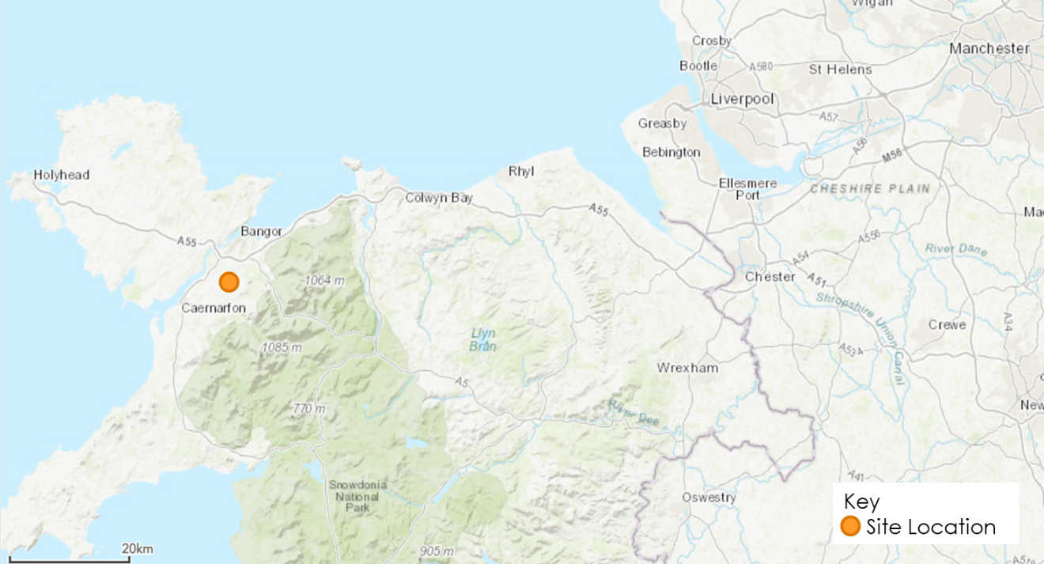
Figure 2-1: Site Location (Regional)
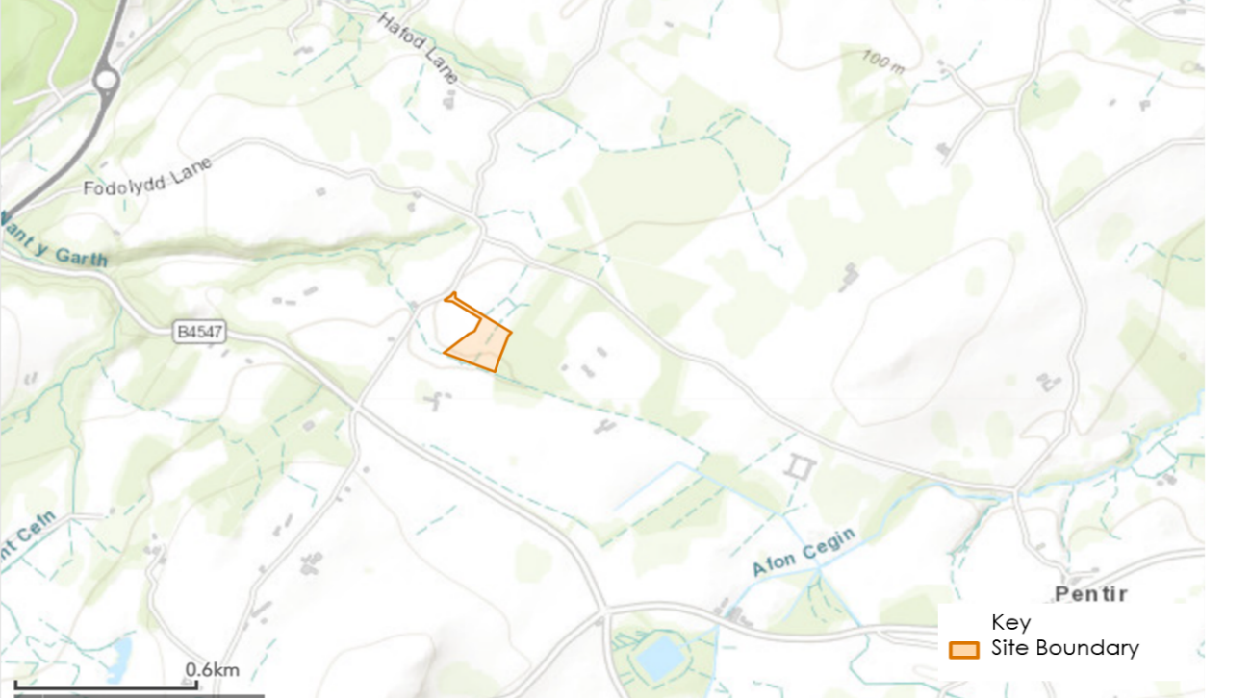
Figure 2-2: Site Location (Local)

Local Access Context
Highways Network
    - The main strategic roads in close proximity of the Site are:
- A55 North Wales Express Way towards Chester to the east and Holyhead to the west. This route provides links to Holyhead, Bangor, Conwy, and Chester.
- A5 towards London in the southeast and Port of Holyhead to the northwest. This route provides links to Holyhead, Bangor, Shrewsbury, Milton Keyes, St Albans, and London.
    - A487 connects to A55 North Wales Express Way at Treborth Interchange. Traffic approaching the Site from A55 will travel southbound along A487 until approaching a roundabout, the traffic will travel southwest along B4547. Traffic will then turn left and travel east along B4547 before turning left onto the access road, Fodolydd Lane. A487 and B4547 are subject to the national speed limit.
    - B4547 runs south of the Site and connects to A487 approximately 1.5km to the northeast of the Site. B4547 is a 3.5km long single carriageway road with continuous road markings.
    - The Site is accessible by Fodolydd Lane, the Site access is located approximately 500m along Fodolydd Lane from B4547. Fodolydd Lane is a narrow-unmarked road and is closely boarded by hedgerows and stone walls.
    - Other roads surrounding the Site mainly consist of rural and agricultural roads with intermittent road markings. Many of these roads are boarded by hedgerows and fencing onto agricultural land.
Public Transport – Rail
    - The nearest railway station to the development is Bangor (Gwynedd), located 7.9 kilometres away. Transport for Wales operates a service connecting to Cardiff Central, London Euston, and Birmingham International. Services from Bangor (Gwynedd) start as early 04:53hrs running as late as 21:00hrs.
    - Bangor (Gwynedd) railway station can be accessed from the development via B4547 and A4087 Caernarfon Road.
Public Transport – Bus
    - The nearest bus stop is located 0.5 kilometres southwest of the development site on the B4547. Bus route 85C (operated by Dilwyn’s Coaches) runs on Sundays and Bank Holiday Mondays, running outbound once in the morning from Deiniolen to Bangor, and inbound once in the evening.
Cycle and Pedestrian Network
    - There are unsegregated pedestrian/cycle route facilities along the section of the B4547 towards the A487. Unsegregated pedestrian/cycle route facilities are present along the A487 towards Bangor, and the A4087. There are no other nearby dedicated or marked pedestrian/cycle paths within close proximity of the traffic and access study area.
    - Due to the Site’s rural location, there is limited opportunities to walk directly to and from the Site from nearby residential areas or from public transport infrastructure. The type and nature of the Proposed Development means that walking trips are anticipated to be minimal.
    - There are no formal cycling infrastructure or routes within the immediate vicinity of the Site. The type and nature of the Proposed Development means that cycling trips are anticipated to be minimal.
Public Right of Way
    - The Public Rights of Way (PRoW) network in the vicinity of the Site has been assessed. There is no ProW within the Pentir Site boundary; therefore, no temporarily closures or diversions of the ProW network will be needed. The Principal Contractor will not have any obligations within the site, as in accordance with the Highways Act 1980. Figure 2-3 below presents the ProW network around the Site.
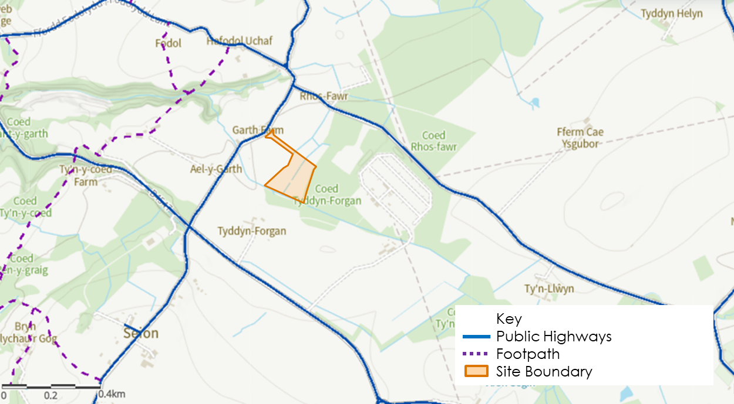
Figure 2-3: Public Rights of Way network around the Site

Considerations and Challenges
    - From a review of available routes, the barriers to access have been assessed and are presented below in Figure 2-4. The barriers to access such as narrow routes, structures and height limits are mostly located on surrounding roads and secondary routes and should not cause significant difficulty for construction access.
    - It is understood that the primary route for construction and operational access would be via A487 and B4547 to the Site. The primary access route, Fodolydd Lane, has been identified as a potential minor constraint due to its narrow width, approximately 3.5m, and based on the maximum width of a Heavy Goods Vehicle (HGV) of 2.55m. Road signage and traffic management supervision will potentially be required due to the likely presence of large and/or slow-moving construction traffic at the Site using Fodolydd Lane. Swept path analysis for Fodolydd Lane is provided in Appendix B. The swept path analysis been undertaken for the largest anticipated vehicles including a 12.3m mobile crane and 16.5m articulated HGV.
    - Vegetation growth along Fodolydd Lane is also a consideration. Trees and hedges may need to be pruned and cut back prior to the commencement of construction on site to facilitate movements by HGVs and ensure the appropriate height clearance can be achieved. Based on an advisory look at the site access visibility splay, see Appendix D, the northern hedge is required to be removed and any planting within the visibility splay must be less than 60cm. This may also depend on the timing of construction i.e., spring/summer during periods of high vegetation growth. Large agricultural vehicles including tractors and trailers with containers use the lane currently therefore access is considered to be achievable.
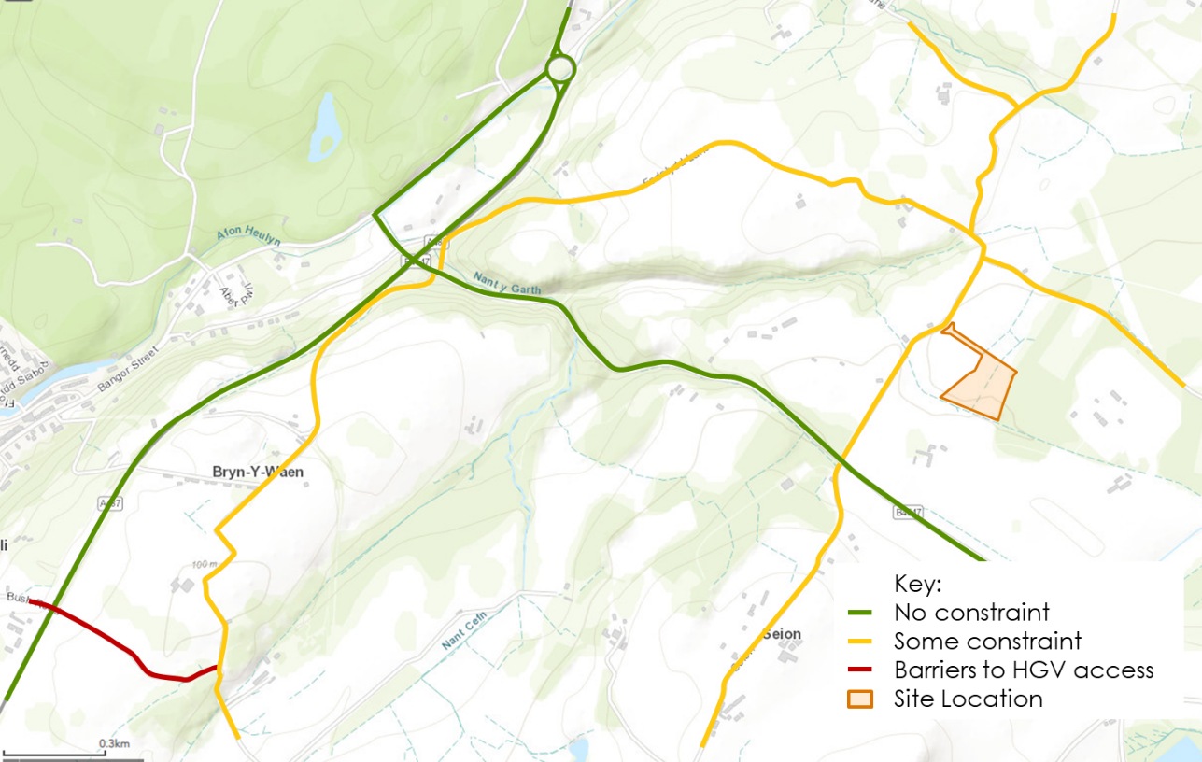
Figure 2-4: Key barriers to access

Construction Programme and Methodology
    - The section provides information on the anticipated construction programme, methodology and working hours. At this stage the construction programme is indicative, and the final programme will be confirmed in a detailed CTMP to be submitted post planning consent.

Construction Programme
    - The indicative construction programme described below is based on the Applicant’s previous experience and professional judgement.
    - The high-level programme is expected to take 10 – 12 months from first Site access to construction completion. Prior to this there will be 3 – 6 months engineering and detailed design activities. However, these are not included in the construction programme below.
    - Table 3-1 below presents the construction programme with a description of each construction phase. The construction programme is indicative and is subject to change and further refinement.
Table 3-1: Indicative Construction Programme
Phase | Phase Description
1 | Site establishment and enabling works. Including the erection of perimeter fencing and implementing ecological/ environmental protection measures;
2 | Installation of temporary construction facilities, temporary security measures, and internal access tracks;
3 | Deliveries and installation of the BESS containers, infrastructure, and associated equipment. Installation of foundations for structures
4 | Commissioning, demobilisation and equipment removal
5 | Landscaping and biodiversity enhancements.

    - Construction could take up to 12 months and Figure 3-1 below reflects this. The construction programme presented in the Gantt Chart below is indicative and is subject to change and further refinement.

Phase No. | Phase Description | Month
 |  | 1 | 2 | 3 | 4 | 5 | 6 | 7 | 8 | 9 | 10 | 11 | 12
1 | Site establishment and enabling works
2 | Installation of construction facilities, security, and internal access tracks;
3 | Deliveries and installation of BESS equipment and foundations
4 | Demobilisation and equipment removal
5 | Landscaping and biodiversity enhancements
Figure 3-1: Indicative Construction Programme Gantt Chart

Construction Components and Method
    - The Proposed Development will consist of an Energy Storage System (ESS) and ancillary equipment. New means of access, welfare and temporary construction and laydowns associated will also be constructed. The Proposed Development will also include landscaping and ecological enhancement areas.
    - The main components to be delivered to Site and installed include:
- 96 x Battery Enclosures (in 24 blocks of 4 units each);
- 3 x Twin MV Skid (each comprised of 2 x Power conversion systems and 1 x MV transformer);
- 6 x Single MV Skid (each comprised of 1 x Power conversion systems and 1 x MV transformer);
- 1 x Monitoring House;
- 1 x Backup Generator;
- 1 x Intake Substation;
- 1 x Transformer;
- 1 x GRP;
- 1 x Toilet
- 3 x Storage containers
- 1 x Welfare facility
- 3 x Spares containers (1 x 20-foot, 2 x 40-foot);
- 10 x CCTV cameras mounted on posts;

Plant and Equipment
    - A range of plant and equipment will be required over the course of the construction period including but not limited to that listed in Table 3-2.
Table 3-2: Construction plant and equipment
Equipment | Function
Dump trucks | Earth distribution as required for any levelling
Vibrating roller | Compacting tracks
Telehandler(s) | Distributing materials
Mobile Crane | Lifting inverters, transformers, battery containers, etc into place
Fuel bowser | Refuel plant as required
Concrete mixer | Foundations for transformers, battery containers, etc.

Working Hours
    - It is anticipated that construction hours on the Site will be:
- 07:00 to 19:00 Monday to Friday
- 07:00 to 13:00 Saturday
- No working on Sundays or on public or bank holidays.
    - Any particularly noisy activities will be limited to 08:00 to 18:00 hours Monday to Friday and 08:00 to 13:00 hours on Saturday. It is unlikely that there will be more than 10 HGV movements per day, even during the most intense period of construction, . There will therefore be minimal impact associated with the construction period of the Proposed Development.
    - Should work need to be undertaken outside of these hours the contractor will obtain permission from the LPA prior to the works taking place.

Vehicle Routeing and Site Access

Routeing of Worksite Construction Traffic
    - Vehicle routes will adhere to the Strategic Road Network (SRN) wherever possible. These vehicle routes have been reviewed with respect to minimising potential impacts, conflicts, and hazards with sensitive points. Suppliers will be made aware that these routes are always required to be followed, unless otherwise agreed or diversions are in place.
    - The main strategic vehicle routes to access the site are:
- A55 North Wales Express Way towards Chester to the east and Holyhead to the west. This route provides links to Holyhead, Bangor, Conwy, Chester and connects to the M56.
- A5 towards Birmingham to the southeast and Port of Holyhead to the northwest. This route provides links to Holyhead, Bangor, Shrewsbury, Birmingham and connects to the M54, M6 and M5.
    - The A487 connects with the A55 North Wales Express Way. Traffic approaching the site from A55 or A5 will travel southbound along A487 until approaching a roundabout, then traffic will travel southwest along B4547.
    - Traffic approaching the site from A487 will travel northbound until approaching the roundabout, then traffic will take the first exit to travel southbound along B4547.
    - Traffic, once on the B4547, will then turn left and travel east along B4547 before turning left onto the access road, Fodolydd Lane.
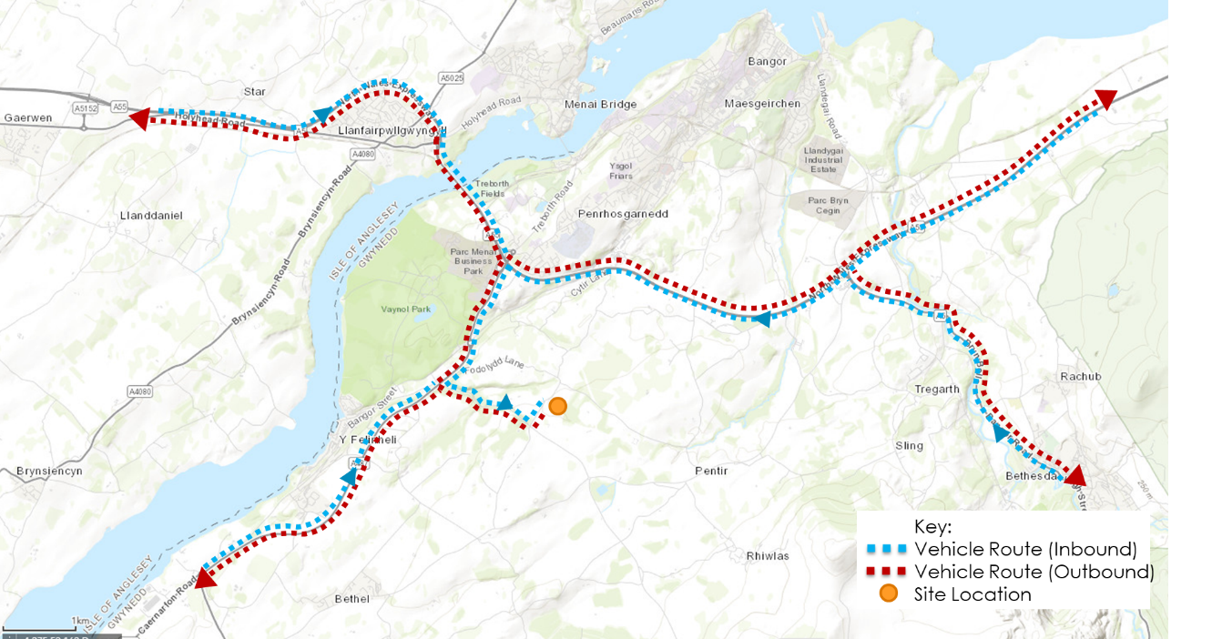
    - An overview of the vehicle routeing plans to the SRN to and from the Site are shown at two scales in Figure 4-1 and Figure 4-2.
Figure 4-1: Strategic Vehicle Routes

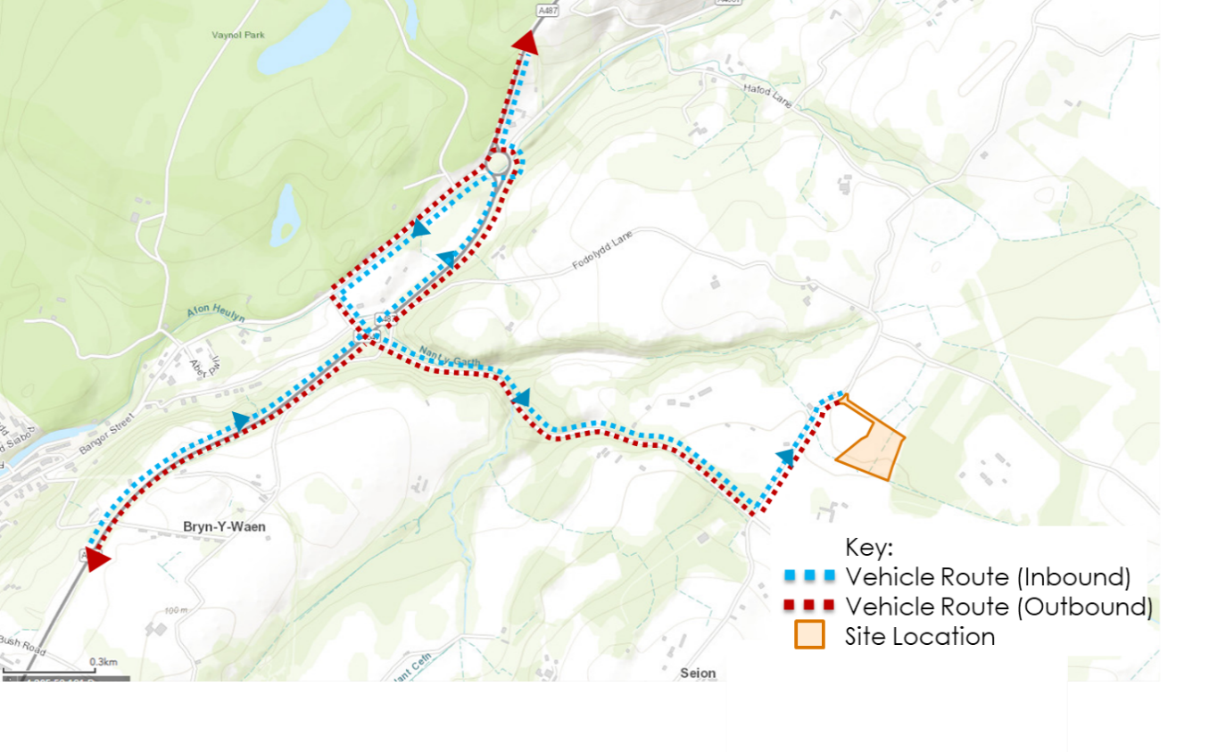
Figure 4-2: Local Vehicle Routes to the Site

Site Access Location
    - The Site access location is shown in Figure 4-3 below and also indicates the access roads within the Site.
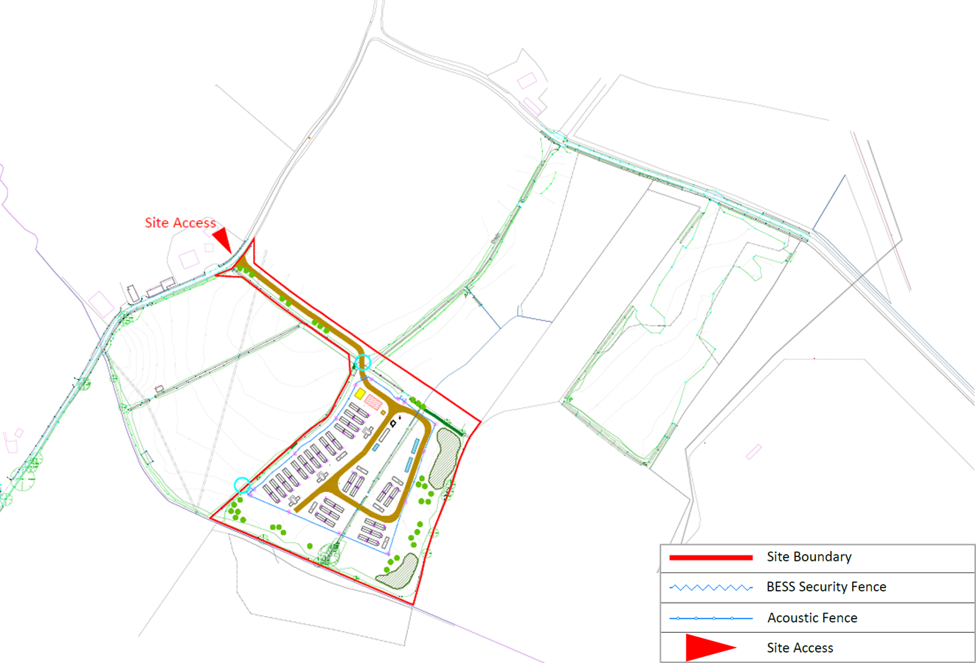
Figure 4-3: Site Layout, Access and Access Road
    - The Proposed Development requires the construction of a new access route from Fodolydd Lane to the Pentir BESS Site. It is proposed that this access is initially created to provide access for the construction phase and then retained as a permanent access for maintenance.
    - The Site will be secured by weld mesh fence and gates (approx. 2.4m in height) and CCTV cameras. All vehicles or loads will be required to enter and exit the Site in forward gear. Adequate provision will therefore be made for vehicles to turn around within the Site.
    - The primary access route, Fodolydd Lane, has been identified as a potential minor constraint due to its narrow width (approximately 3.5m) and based on the maximum width of an HGV (2.55m). Road signage and traffic management supervision will be potentially required due to the likely presence of large and/or slow-moving construction traffic at the Site from Fodolydd Lane. The swept path analysis for Fodolydd Lane is provided in Appendix B. The swept path analysis been undertaken for the largest anticipated vehicles including a 12.3m mobile crane and 16.5m artic. The swept path analysis indicates that all vehicles can safely achieve the turning movement between the B4547 and Fodolydd Lane. The access is also suitable for emergency services and a swept path analysis for a fire tender through the primary access route has been conducted to confirm this (Appendix A, B, and C). Therefore, no junction improvement works are needed to accommodate construction traffic.
    - Vegetation growth along Fodolydd Lane is also a consideration. Trees and hedges may need to be pruned and cut back prior to the commencement of construction on site to facilitate movements by HGVs and ensure the appropriate height clearance can be achieved. This may also depend on the timing of construction i.e., spring/summer during periods of high vegetation growth. Large agricultural vehicles including tractors and trailers with containers use the lane currently therefore access is considered to be achievable.
    - There will be an internal access track within the site formed using a layer of permeable crushed stone. Geosynthetic reinforcement or soil stabilisation may be used to reduce the depth of the track construction. The surface will be a compacted granular material (crushed rock) up to an approximate thickness of 0.3m, dependent on the ground conditions. The tracks will measure between 3.5m and 6.5m wide. Width will increase at bends and at the entrance point.

Temporary Road Signs
    - During the construction phase, signs will be installed to warn road users of the works access, and the likely presence of large and/or slow-moving construction traffic at the site from Fodolydd Lane. Temporary signing will be erected confirming the site access route to contractors and outside suppliers. The Contractor shall also install general information signs to inform road users of the nature and location of the works, and also to provide contact details.

Abnormal Indivisible Loads
    - Abnormal Indivisible Loads (‘AILs’) are not anticipated. However, should an AIL be required, it will be the responsibility of the haulier, in collaboration with the affected Police and LHAs, to determine the routeing and requirements of the AIL movement. These will be determined by the configuration of the load, depending on its height, width, weight, and length. The need for escort vehicles would be determined through that process. The haulier will be required to make use of relevant guidance such as the FORS abnormal load toolkit and the ESDAL or AbHaulier notification processes.

Strategies to Reduce Impacts

Planned Measures
    - Table 5-1 sets out the measures to be implemented to manage vehicle visits and delivery/ collections at the site. Further detail is provided in the subsequent paragraphs.
    - The Site Planned Measures Checklist below ensures that the CTMP is effective in achieving the aims of reducing environmental impact, road risk, congestion, and cost. As per best practice guidance, the measures are categorised as follows:
- Committed – indicates a measure that shall be implemented;
- Proposed – indicates a measure that is feasible and shall be studied further to determine its practicality; and
- Considered – indicates a measure that is not currently relevant (or may be in the future).
Table 5-1: Site Planned Measures Checklist
Planned Measures Checklist | Committed | Proposed | Considered
Measures influencing construction vehicles and deliveries
Vehicle safety and environmental standards and programmes | X
Adherence to designated routes | X
Delivery scheduling |  | X
Retiming for out of peak time deliveries |  | X
Retiming for out of hours’ deliveries |  |  | X
Use of holding areas and vehicle call off areas |  |  | X
Measures to encourage sustainable freight
Freight by Water |  |  | X
Freight by Rail |  |  | X
Material procurement measures
Design for Manufacture and Assembly (DfMA) and off-site manufacture |  | X
Reuse of material on site |  | X
Smart procurement |  | X
Collaboration amongst other sites in the area |  |  | X
Implement a staff travel plan |  |  | X

Measures Influencing Construction Vehicles and Deliveries
Safety and Environmental Standards and Programmes
    - The Applicant is committed to ensuring all contractor and sub-contractor vehicles arriving at site comply with relevant safety measures and requirements relating to Work Related Road Risk.
    - The Principal Contractor is responsible for ensuring industry best practice is adopted to support the works at the development, wherever possible. This will be achieved through the procurement process whereby the Principal Contractor and its sub-contractors are encouraged to be members of, or signatories to, the relevant best practice schemes and initiatives including, for example:
- Considerate Constructors Scheme (CCS) – promotes best practice that relates to on-site activities and those in the vicinity of the site. It is noted that the Site will be registered under this scheme or a similar locally recognised certification scheme.
- Fleet Operator Recognition Scheme (FORS) – FORS is a voluntary accreditation scheme for fleet operators which aims to raise the level of quality within fleet operations, and to demonstrate which operators are achieving exemplary levels of best practice in safety, efficiency, and environmental protection.
- Construction Logistics and Community Safety (CLOCS) – CLOCS brings the construction logistics industry together to revolutionise the management of work-related road risk and ensure a road safety culture is embedded across the industry. The aim is to help protect vulnerable road users who share the roads with construction vehicles.
Adherence to Designated Routes
    - Vehicle routes to and from the Site via the local and SRN are as specified in Section 4. These access routes have been reviewed with respect to physical obstructions and hazards which could restrict access for larger construction vehicles.
    - Suppliers will be informed of the designated route when orders are placed to ensure drivers are fully briefed on the required route to take. The supplier will be made aware that these routes are required to be followed at all times, unless agreed or alternate diversions are in place by the Police or Local Highway Authorities.
Delivery Scheduling
    - Delivery Scheduling for road traffic movements will be managed by the Principal Contractor’s logistics team. An electronic or paper-based Vehicle Booking Management System (‘VBMS’) will be implemented to book and manage vehicles visiting the Site. The VBMS will record all details relevant to the vehicle visit, which are then available for the inclusion in monitoring reports if required. The data recorded will align with the monitoring specification as set out in Section 7.
Retiming of Deliveries Outside Peak Traffic Times
    - Retiming of deliveries outside peak traffic times may improve the operational efficiency of the construction Site, as well as lessening the impact of vehicle activity on the neighbouring area. The Principal Contractor will, through the VBMS, look to schedule deliveries to Site to times outside the morning peak (i.e., outside 07:00hrs – 09:00hrs) where practicable.
Use of Holding and Vehicle Call Off Areas
    - The likely quantity of materials that will be needed and the number of estimated vehicles trips during the works does not warrant a vehicle holding or call-off area for managing movements.
Use of Logistics and Consolidation Centres
    - The number of expected vehicle trips and likely quantity of materials during the works is not considered sufficient to warrant use of a dedicated consolidation centre. It is also considered that the Principal Contractor will seek to use contractors and suppliers who consolidate their deliveries through their supply chains. Bulk deliveries and preassembly will help ensure fewer, and fuller vehicles arrive at site; therefore, reducing the overall number of vehicle trips.

Measures to Encourage Sustainable Freight
Freight by Water
    - The Site is not within 100 metres of a navigable waterway; therefore, it is not considered feasible to transport freight by water for this development. However, the Principal Contractor will seek to use suppliers for products that use waterborne deliveries as part of their supply chain.
Freight by Rail
    - The Site is not within 100 metres of a useable rail head or siding, so it is not considered that transporting freight by rail is appropriate for this development. However, the Principal Contractor will seek to use suppliers for products that use rail deliveries as part of their supply chain.

Material Procurement Measures
DfMA and Off-Site Manufacture
    - The potential to use prefabricated assemblies and techniques would be considered as an approach to reduce the number of construction vehicle movements, once a Principal Contractor has been appointed. A decision as to how prefabrication might be integrated into the construction process would be included in the detailed CTMP.
Re-use of Material on Site
    - Consideration would be given to the reuse of excavated material for cabling works filling, depending on its suitability - e.g., potential contamination. Where practicable, the project will seek to maximise the reuse of suitable soils for landscaping, to reduce waste disposal.
Smart Procurement
    - Where appropriate suppliers are available and suitable contracts can be negotiated, materials, equipment and plant will be sourced from local suppliers. Suppliers who can demonstrate working arrangements that align with the CTMP objectives, such as reducing vehicle movements, will be preferred.

Other Measures
Collaboration Amongst Other Sites in the Area
    - The Applicant will consider working with other construction site contractors in the vicinity off the Site. This could include initiatives such as the use of a sharing delivery scheduling information to manage vehicle movements effectively and potentially using the same supplier for specific materials where practical.
    - The Dinorwig to Pentir underground cable replacement project has been consented by Gwynedd Council and is within the vicinity of the Site, with duct and cable removal and installation works on A4086 and A4244. These works do not impact vehicles travelling to the Proposed Development and there may be opportunity to collaborate with National Grid to manage vehicle movements effectively. This will be kept under review as the project progresses.

Estimated Vehicle Movements
    - This section provides an overview of the types of construction vehicles expected to access the Site as well as estimated construction vehicle trips to site over the duration of the construction programme. These estimates are indicative and subject to change and further refinement. This information will be provided in a detailed CTMP submitted post consent.

Construction Vehicles Accessing the Site
    - It is expected that a range of construction vehicle types would access the site to enable construction, of the development. The include but are not limited to the following:
- Light Goods Vehicles (LGVs) i.e., vans and small flatbeds – movements for plant maintenance, PPE, fixings/small components, sundry items, canteen supplies, couriers, post/parcels;
- Heavy Goods Vehicles (HGVs) i.e., 2-6 axle rigid or articulated lorries and mobile cranes - movements of materials/component deliveries, plant deliveries, spoil removal, concrete, aggregate supplies, cabling, containerised equipment, fencing etc;
    - Abnormal indivisible loads are not anticipated to be required.

Estimated Construction Vehicle Numbers
    - The Applicant has indicated based on previous experience that the construction works during the enabling and civil works (Phases 1 and 2) could require up to 10 HGV deliveries (20 movements) per day, including concrete deliveries. However, this number of deliveries is unlikely to be required every day during this period.
    - During delivery of the BESS and associated equipment (Phase 3), the Applicant has indicated that around 10 – 15 deliveries (20 – 30 movements) could be required over a period of 3 – 4 days. Significantly less deliveries would then occur on a daily basis over the remaining duration of Phase 3.
    - During the latter phases of the construction (Phases 4 and 5), which would involve commissioning and demobilisation followed by landscaping work, the Applicant has indicated that there would be limited HGV movements. The works required would be carried out by individual personnel doing electrical and commissioning work over a period of 3 – 4 months.
    - It is recognised that a flat profile across the programme is unlikely and there will be peaks in activity associated with overlaps in the construction programme and more transport intensive activities taking place.
    - An initial construction vehicle movement profile has been developed in the table below. The vehicle numbers shown are for a peak day and month and two-way movements i.e., a vehicle arriving at site and departing again. The figures should be considered as a worst case and represent a robust assessment.
    - These figures should be considered indicative at this stage and will be developed further once a Principal Contractor has been appointed and the final construction programme and method are known. This information will be provided in a detailed CTMP submitted post planning consent.

Table 6-2 Estimated Construction Vehicles – Peak Daily and Monthly
Phase No. | Phase Description | Duration (months) | Peak Daily  (two way) |  | Peak Monthly  (two way)
 |  |  | HGVs | LGVs | HGVs | LGVs
1 | Site establishment and enabling works | 3 | 20 | 6 | 240 | 64
2 | Installation of construction facilities, security, and internal access tracks; | 3 | 20 | 6 | 240 | 64
3 | Deliveries and installation of BESS equipment and foundations | 6 | 30 | 8 | 320 | 78
4 | Commissioning, demobilisation, and equipment removal | 3 | 12 | 4 | 110 | 48
5 | Landscaping and biodiversity enhancements | 3 | 4 | 12 | 48 | 110

    - Table 6.2 indicates that there would likely be a peak in vehicle movements when there is overlap between construction Phases 1 and 2 and subsequently Phases 2 and 3.

Estimated Construction Workforce Numbers
    - It is estimated that there will be a maximum of approximately 30 – 40 people on the Site per day. The number of staff on Site will vary subject to the overall programme of works.
    - It is likely based on the rural nature of the Site that most construction workers will drive, and it is estimated, based on previous project experience, that around 1/3 (33%) of construction workers would car share. It is considered reasonable to apply this car share mode split to the Proposed Development. It is also important to note that some workers will travel to Site in work vans which will account for a combined staff and construction vehicle trip, this will reduce the number of vehicles travelling to Site.
    - It is anticipated that construction staff will be locally based where reasonably practicable and would likely arrive at site via the A5 and A55 or using the A487 travelling northbound. Workers will arrive at site between 07:00 – 08:00 therefore missing the AM network peak hour.
    - It is expected that workers will leave the Site across the afternoon period depending on their working hours and the activities taking place on Site. Therefore, the departure profile will be dispersed across several hours.
    - The construction worker numbers, and travel mode share are indicative at this stage and will be subject to change and further refinement. This will be developed further once a Principal Contractor has been appointed and the final construction programme and methodology are confirmed. This information will be provided as part of a detailed CTMP to be submitted post planning consent.

Implementing, Monitoring and Updating

Overview
    - This section provides an overview of how the CTMP will be implemented, monitored and, if necessary, updated. The data collected can be provided to Gwynedd Council if required.
    - A Construction Logistics Manager, appointed by the Principal Contractor, will be responsible for implementing the CTMP. It is expected that a record will be kept of the vehicle visits to Site to provide evidence on the number and type of vehicles, and the efficiency and accuracy of the visits made. This information will help highlight the actual impacts of visits against predictions and identify areas where improvement or remedial measures may be needed. Through the Vehicle Booking Management System and site gate checks the following information will be collected and analysed:
Vehicle Bookings
    - Vehicle movement bookings to Site will include the following information:
- Compliance that vehicle was scheduled or arrived unplanned;
- Total vehicles accessing the site by day;
- Vehicle type / size / age;
- Vehicle arrival, departure, and dwell time; and
- Delivery / collection accuracy compared to schedule.
Breaches, Complaints and Non-compliance
    - Focussing on the following indicators:
- Vehicle routeing;
- Unacceptable queueing; and
- Unacceptable parking.
Safety
    - Focussing on the following indicators:
- Logistics-related accidents;
- Record of associated injuries; and
- Vehicles and operations not meeting safety requirements.

Compliance Arrangements
    - For those suppliers and hauliers that fail to follow advice to avoid delivering during peak periods or conform to other instructions, the Site manager will liaise with these operators to seek improvements in their level of compliance. Should no improvement be forthcoming the supplier may be removed from the contract.
    - An incident/ complaints register will be created into which incidents/ complaints can be recorded. Once entered, the incident / complaint will be dealt with using the normal procedures that the Principal Contractor has in place for its development Site construction works.

Reporting and Review Arrangements
    - Reviews of vehicle activity will be held between the Site management group using the data collected as stated above. Where an issue or compliant is identified the Site management group and the Construction Logistics Manager will implement remedial actions to provide a resolution.

Conclusion
    - Stantec has been commissioned by Lightsource bp to produce an outline Construction Traffic Management Plan (oCTMP) in support of the development of a 57MWac Energy Storage System (ESS) at Pentir, west Wales.
    - The Proposed Development is considered to be well placed for construction vehicles to take advantage of the surrounding transport network with good connections to the SRN, including, to the A5 and A55 National Wales Express Way.
    - This outline CTMP demonstrates that adequate arrangements can be put in place to minimise and manage the associated environmental and traffic impacts from the construction phase of the Proposed Development.

- Swept Path Analysis - B4547 Junction
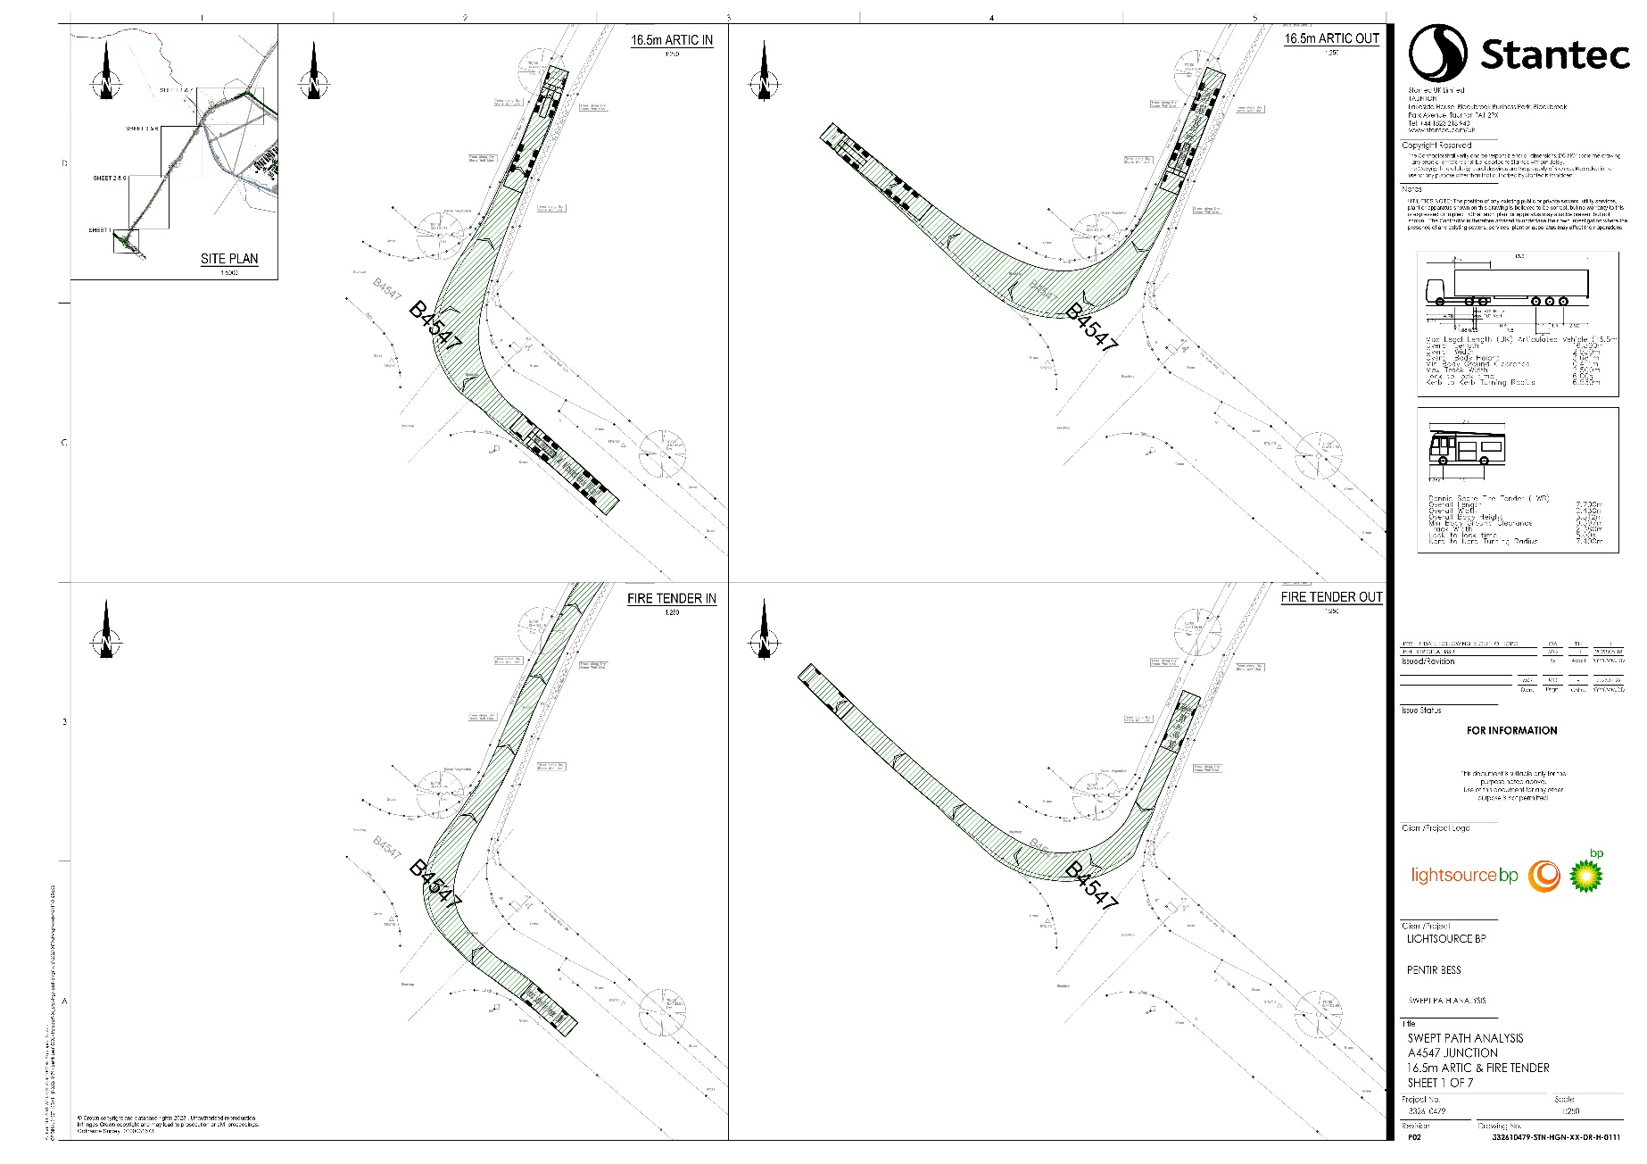

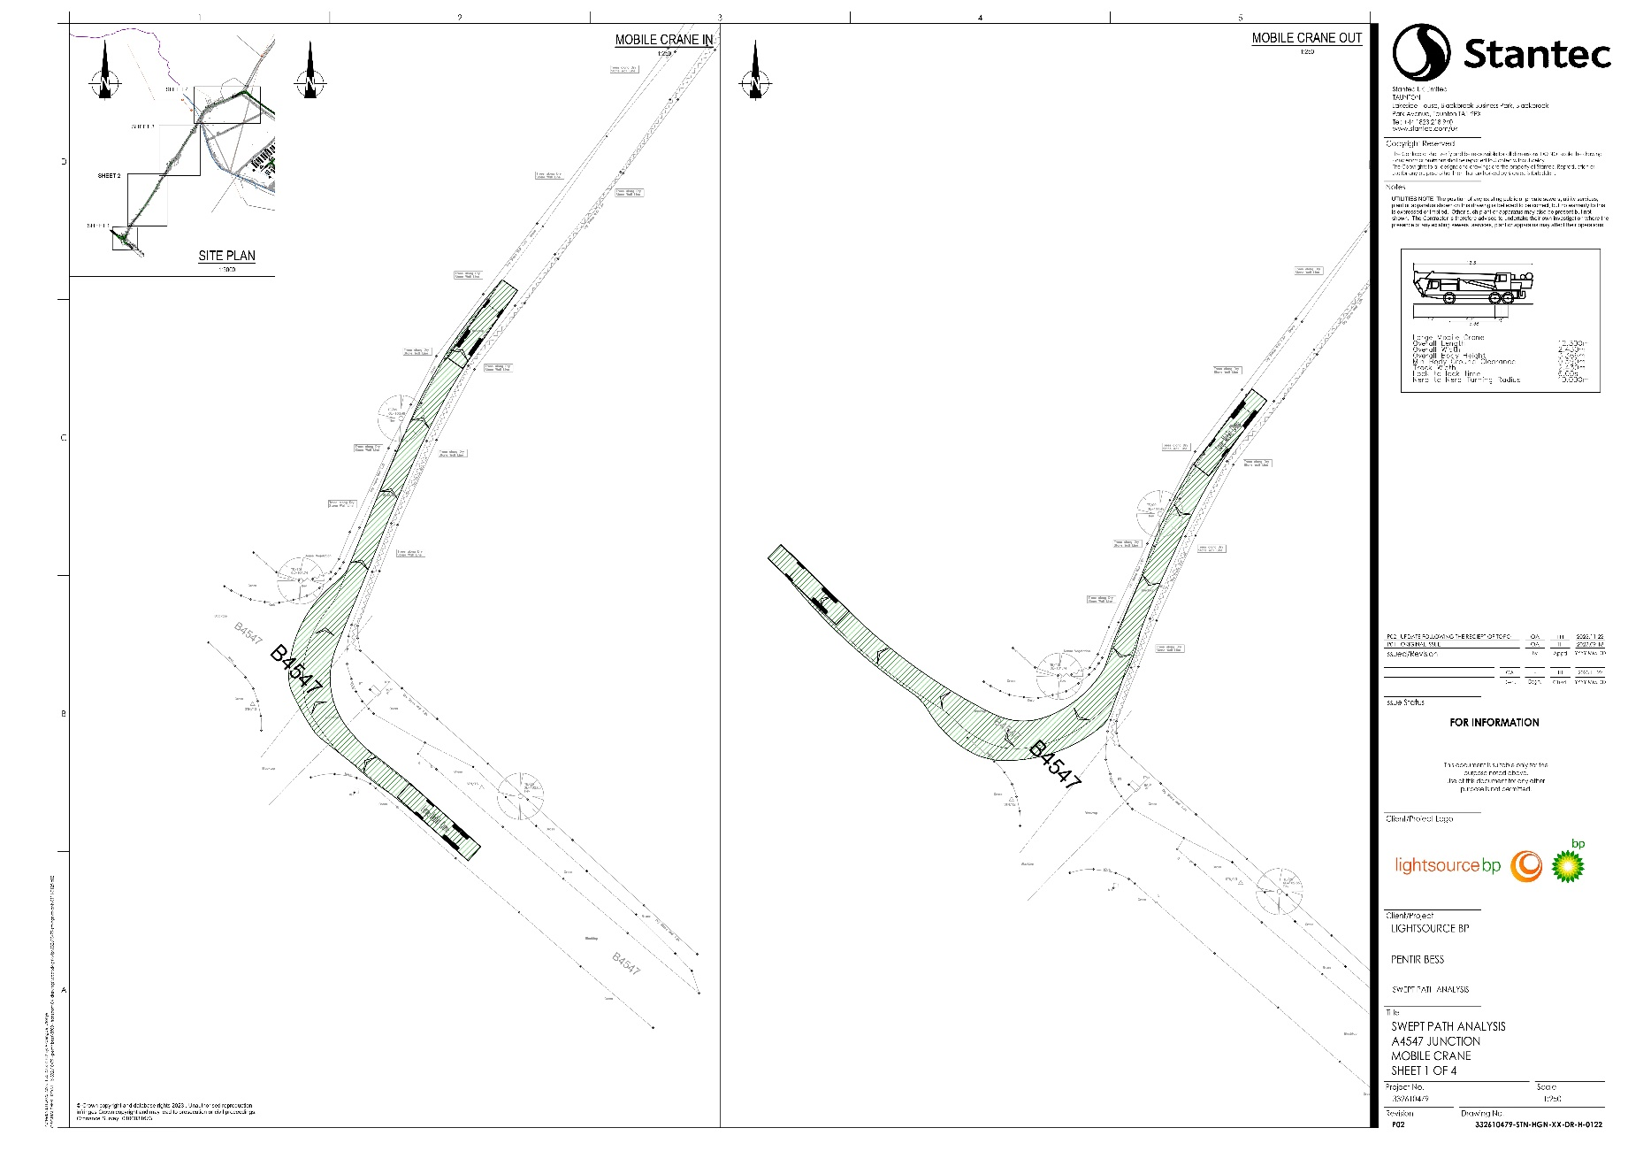
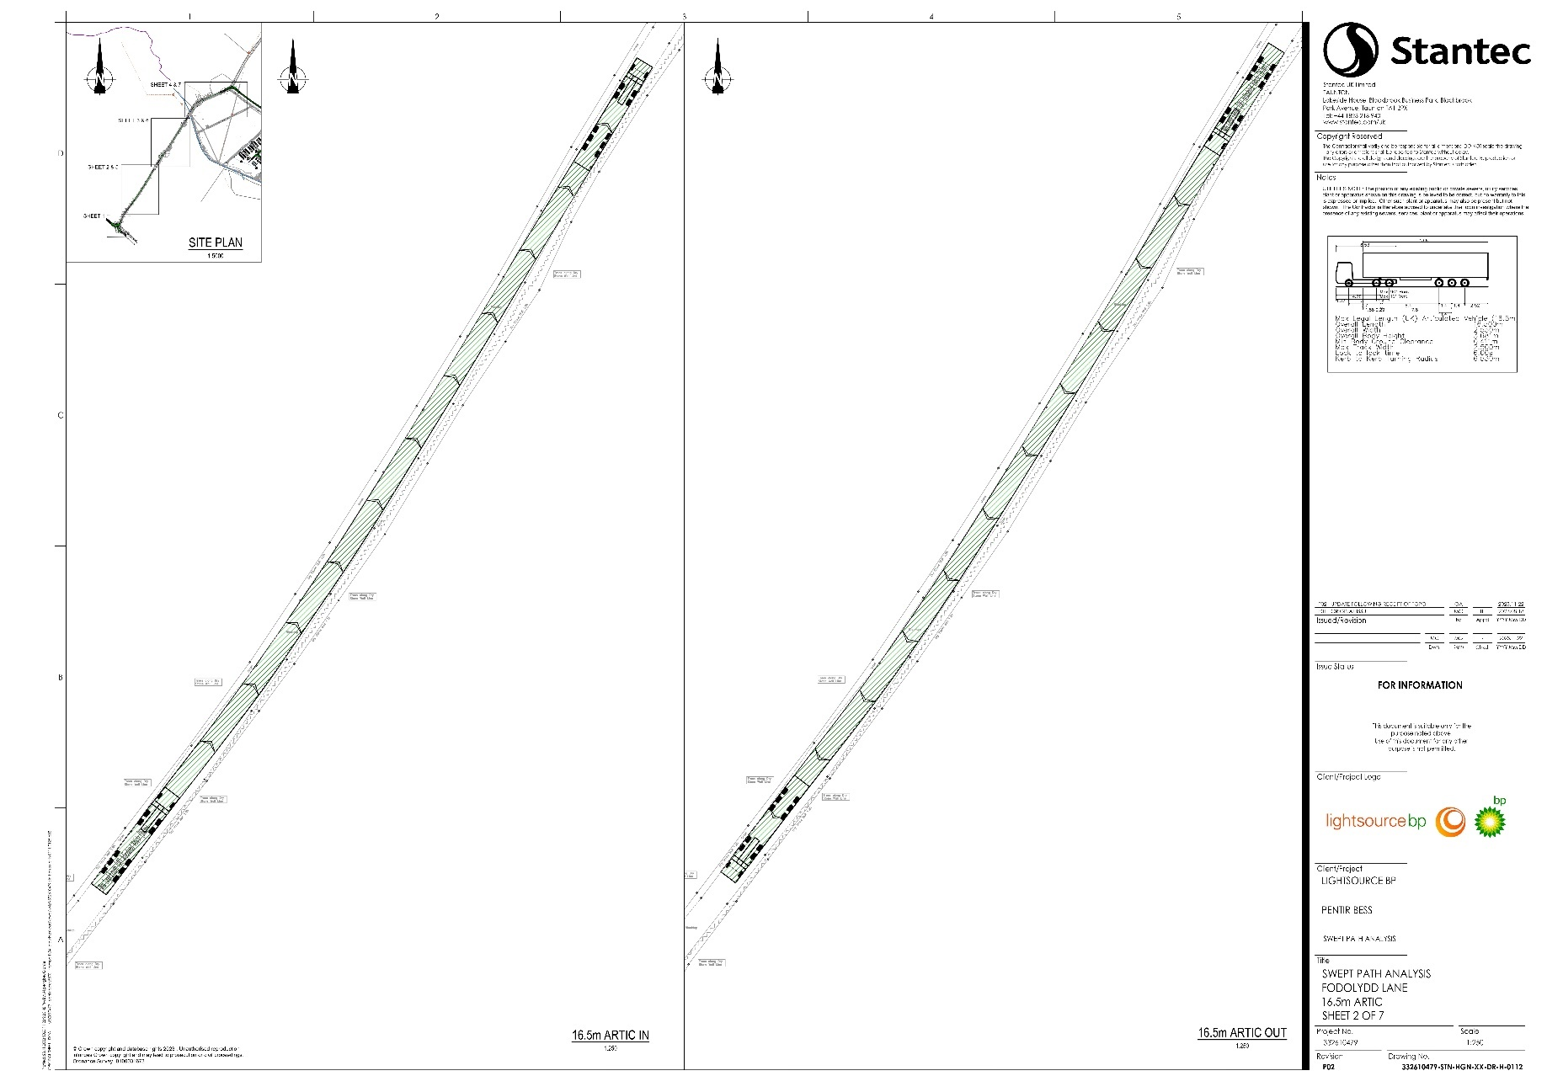
- Swept Path Analysis - Fodolydd Lane

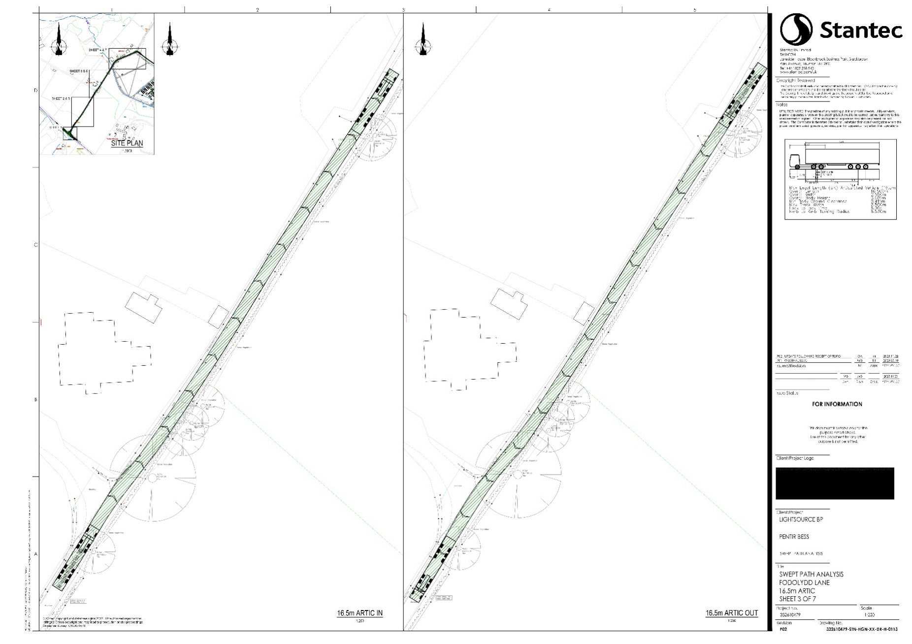
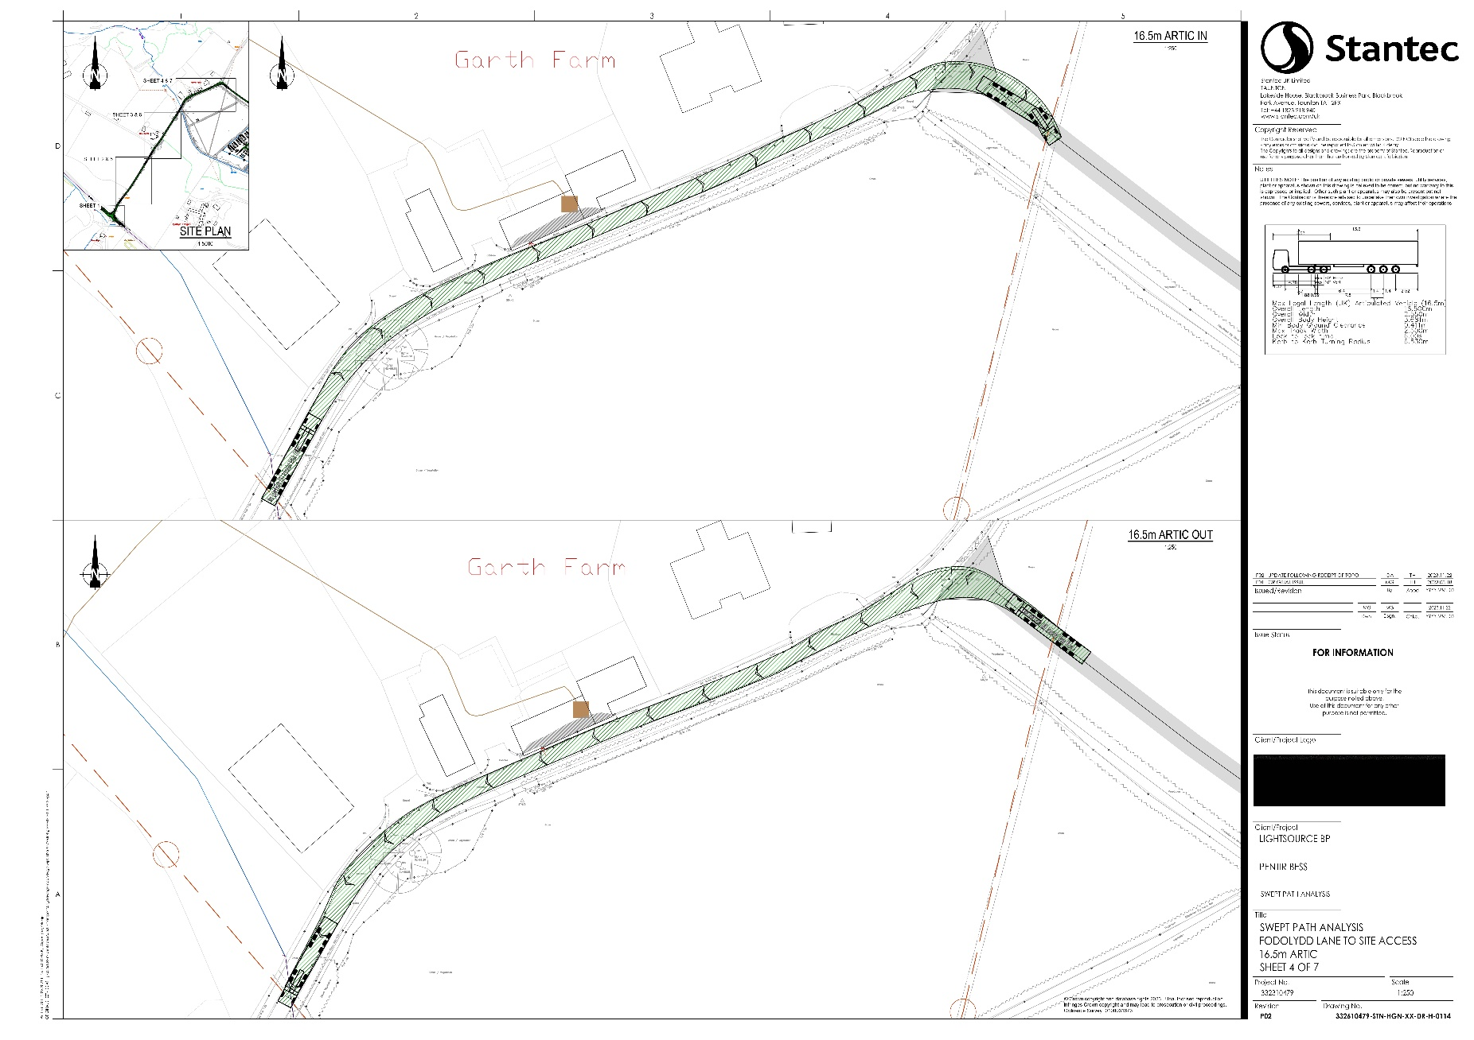
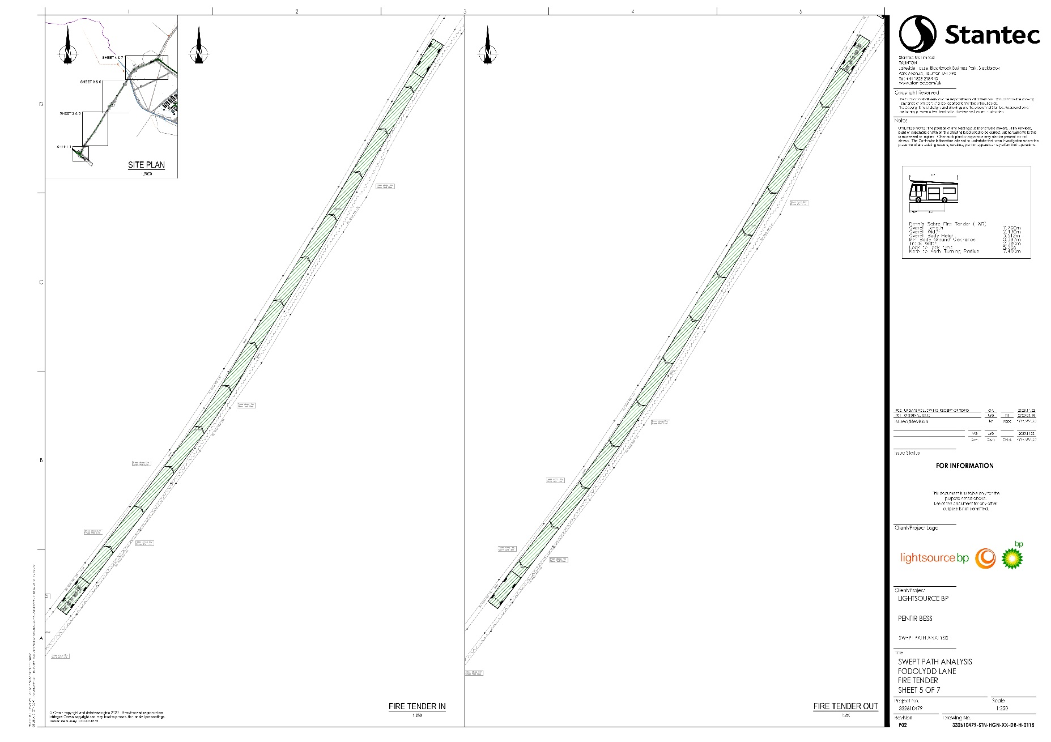
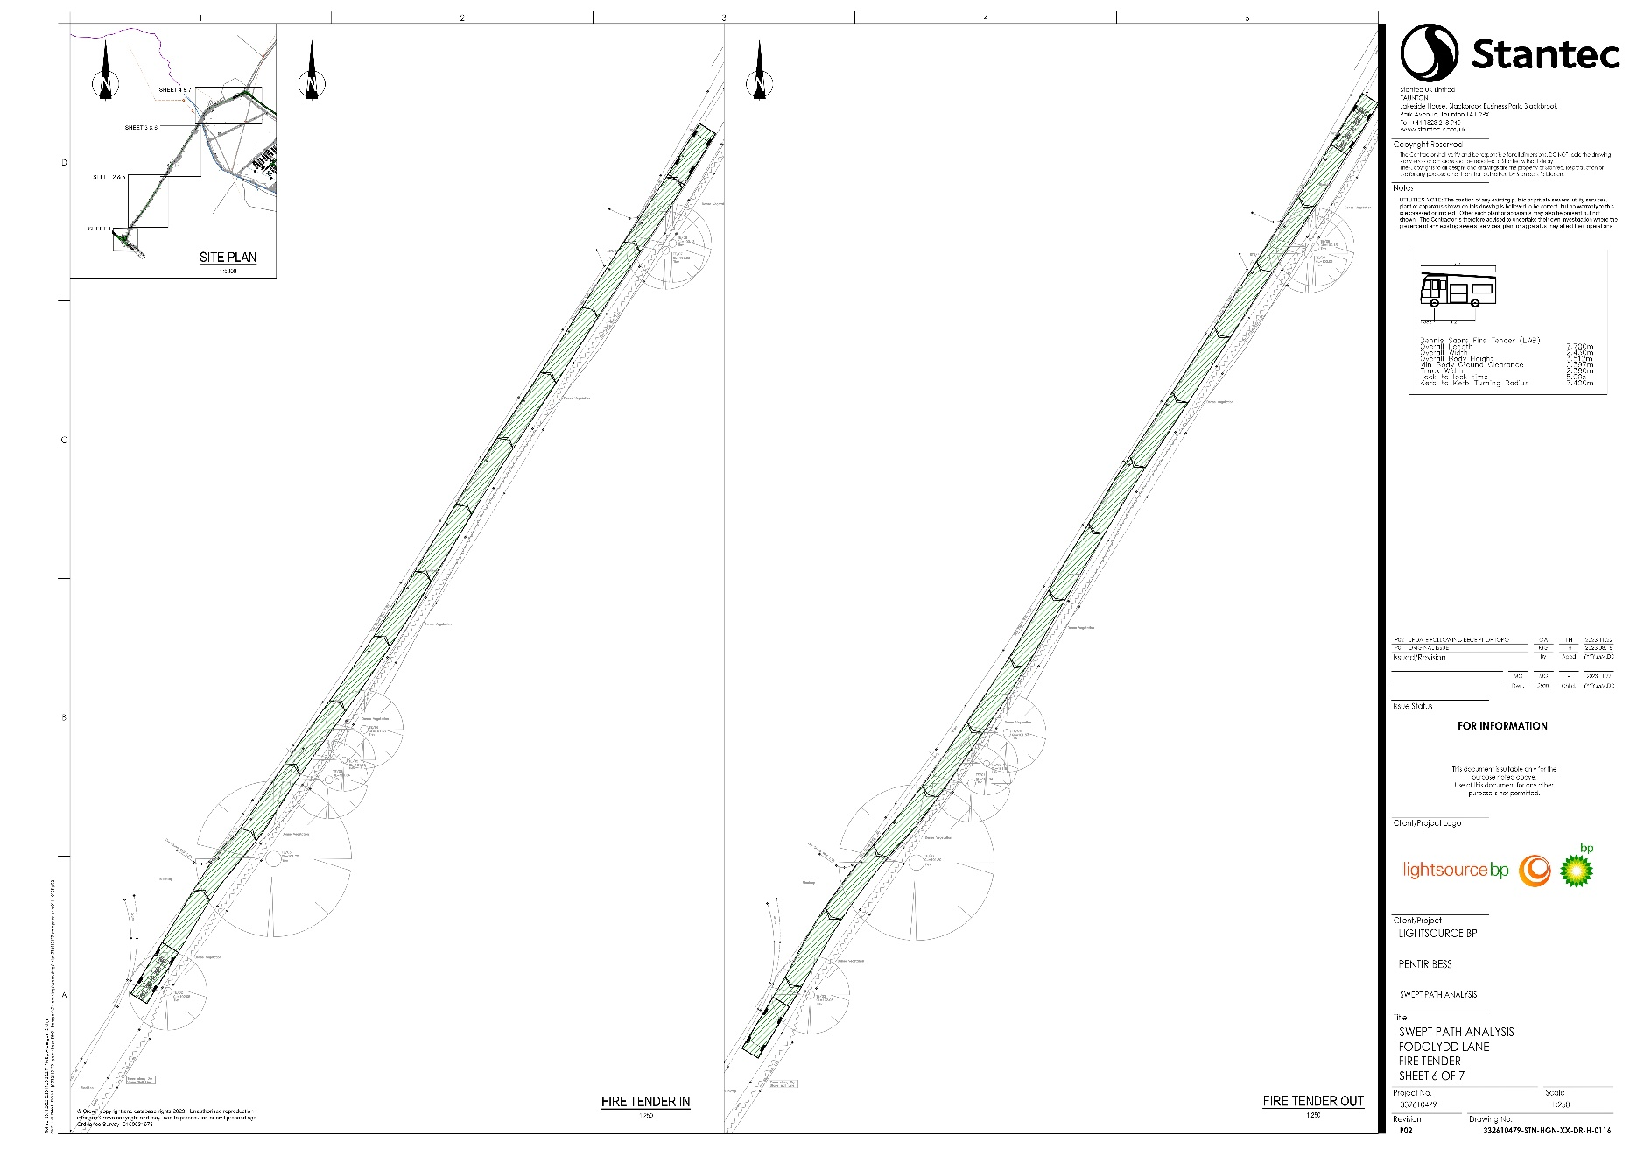
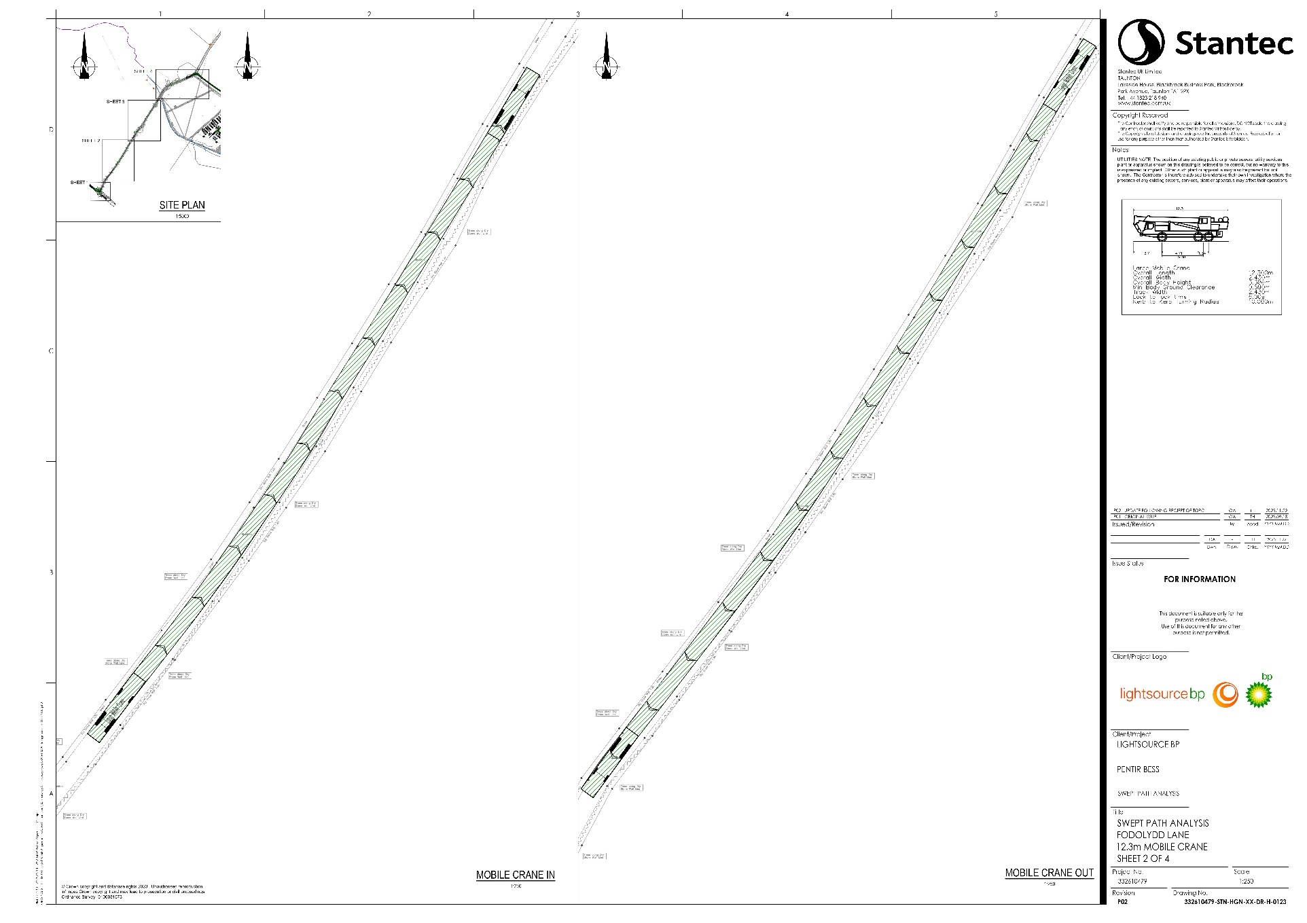
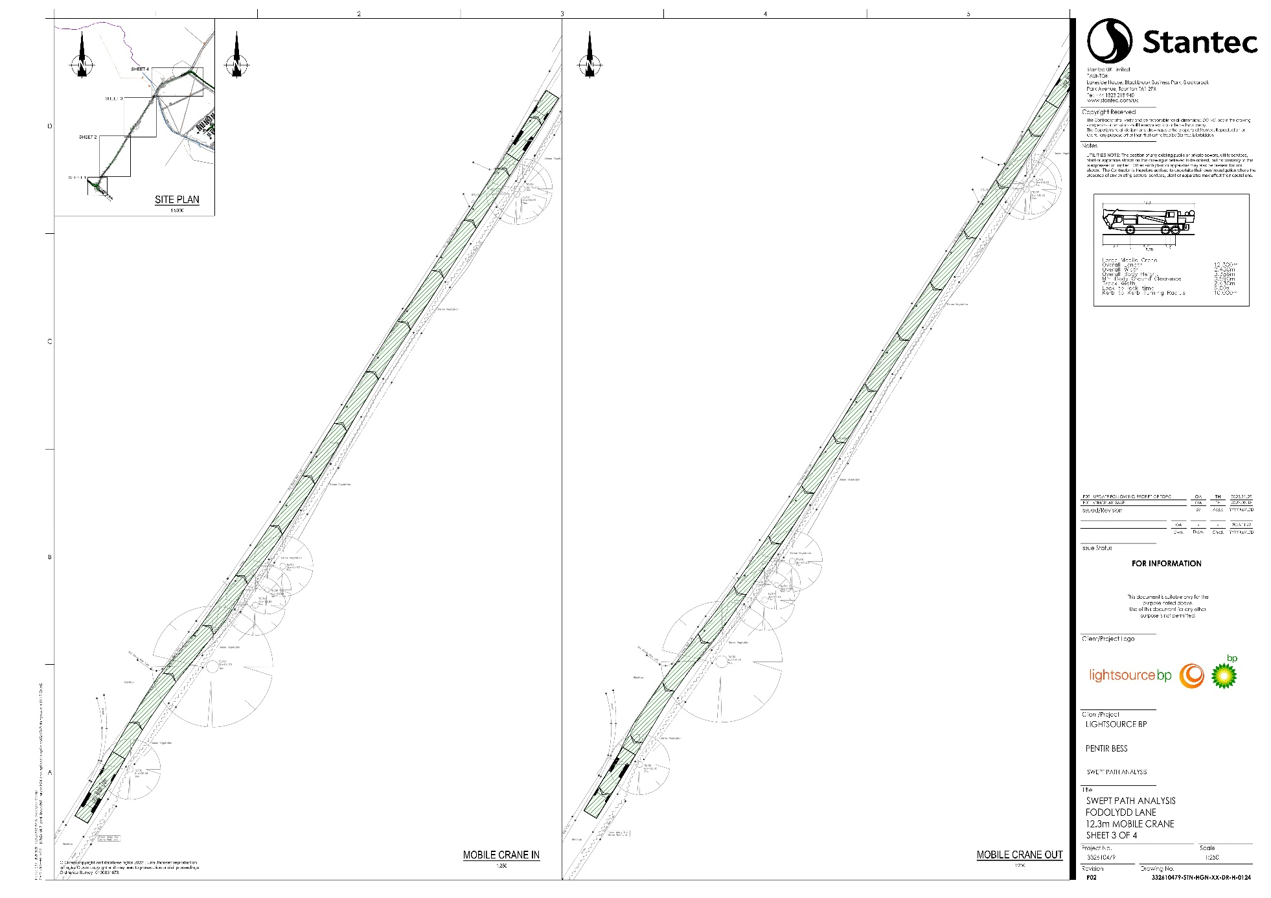
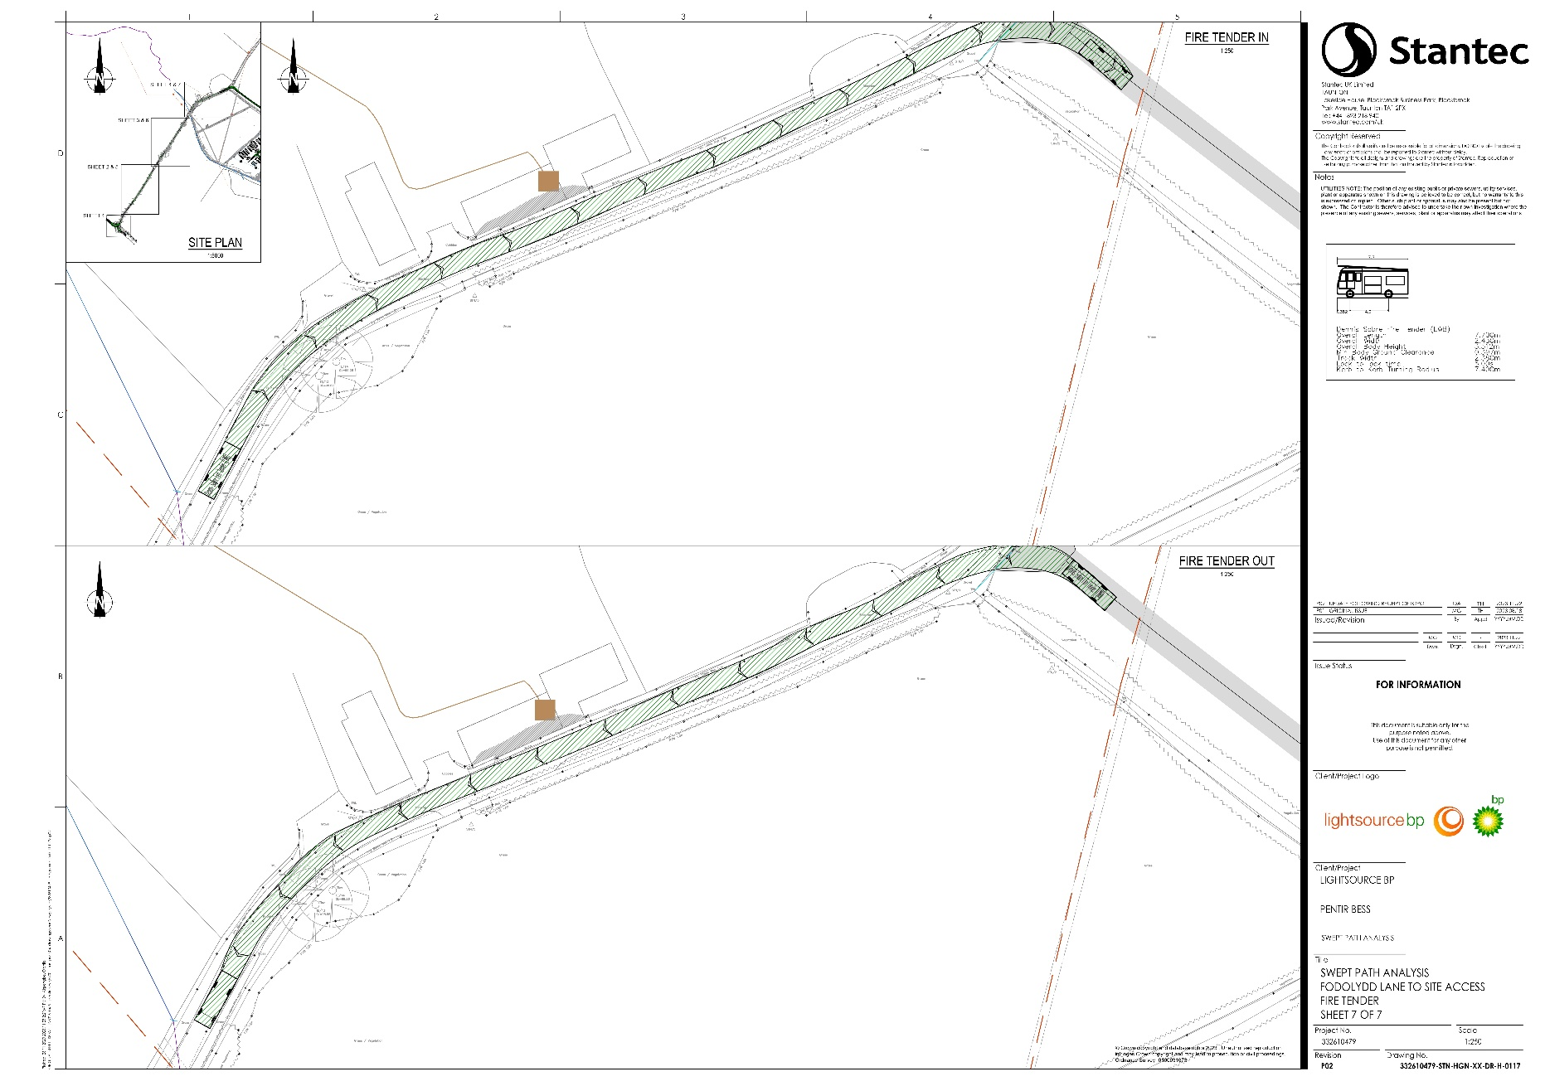
- Swept Path Analysis – Site Access

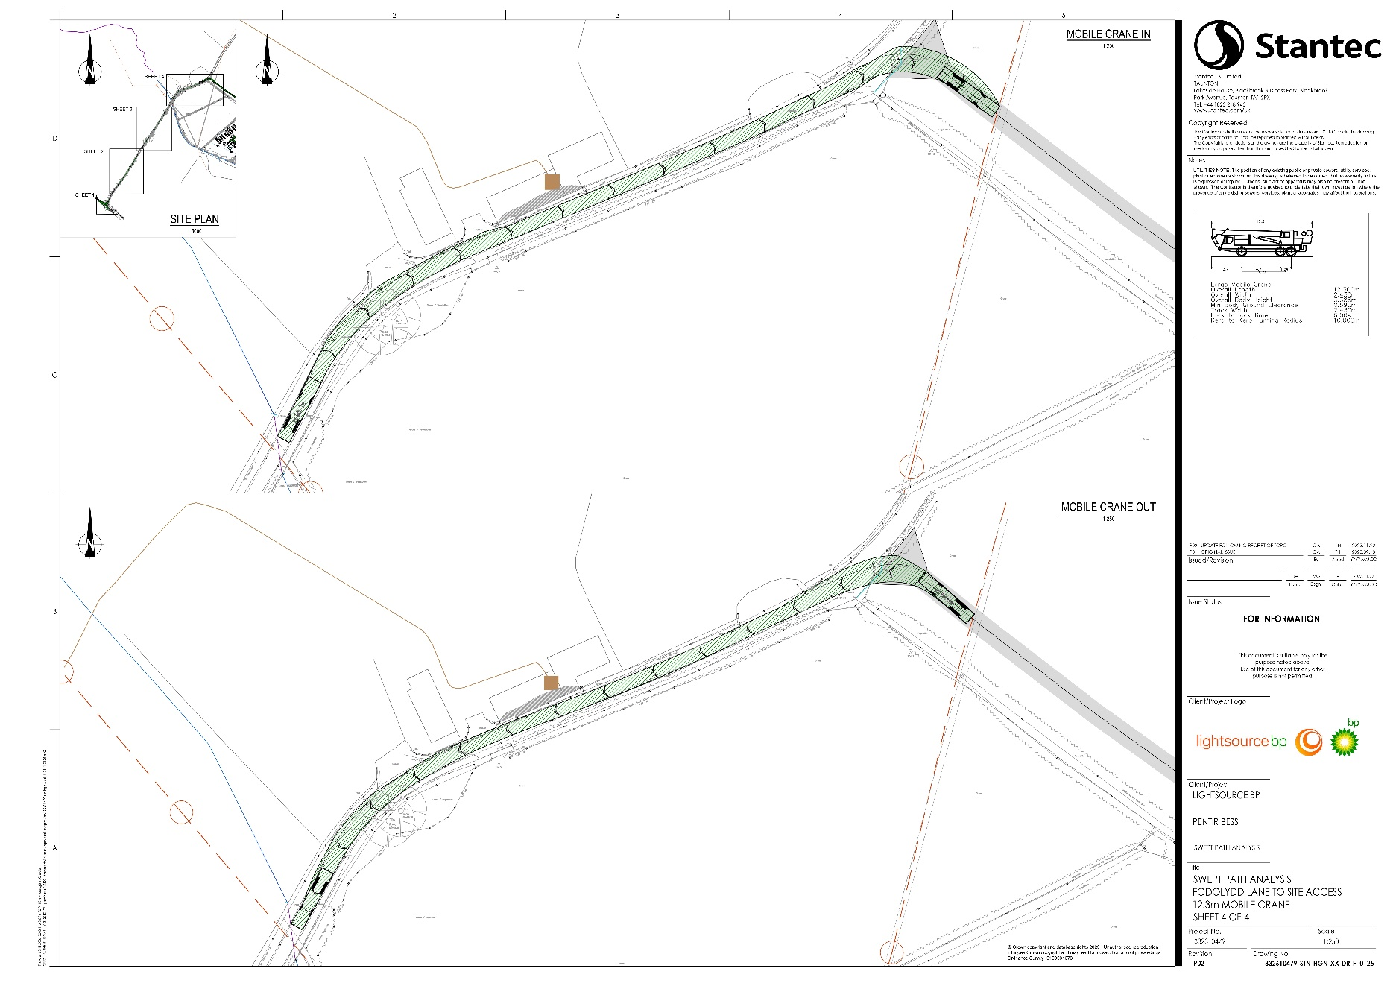
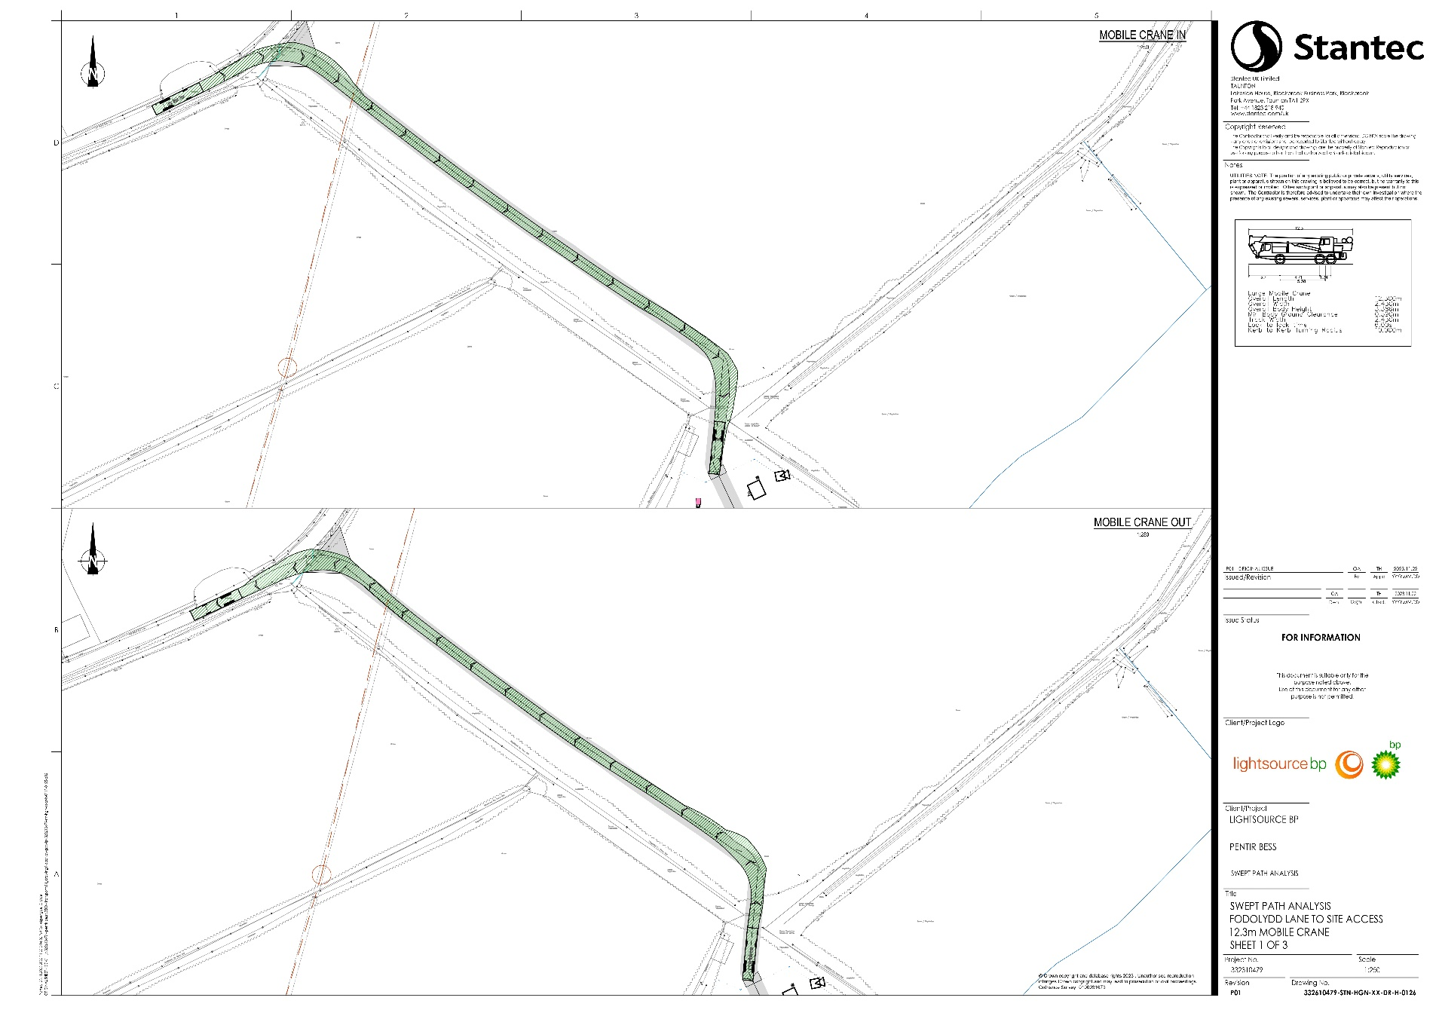
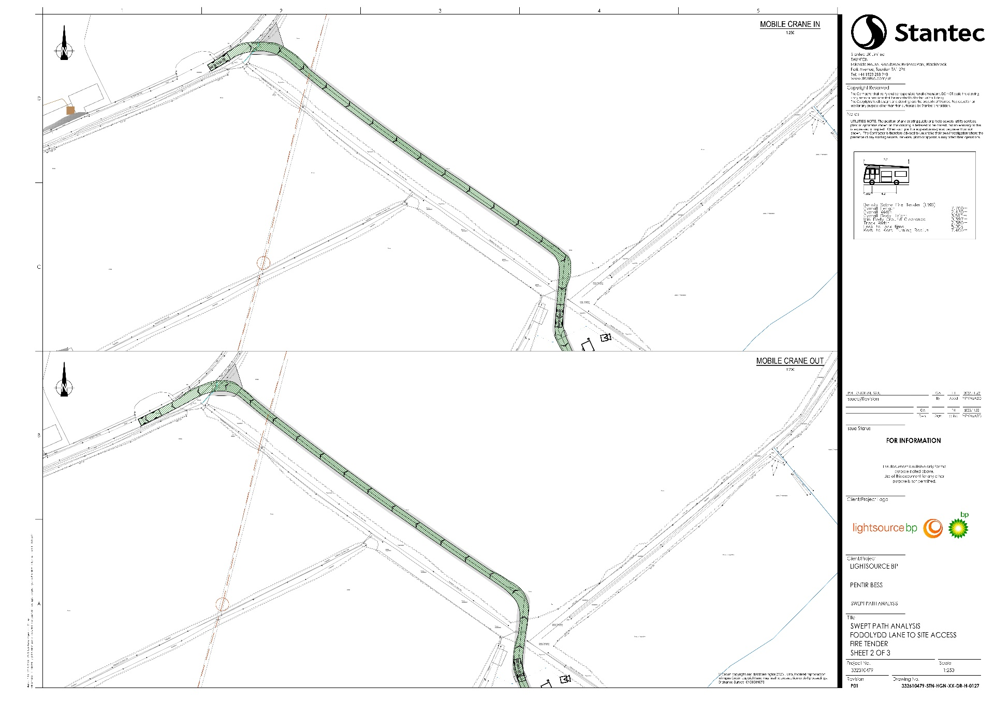
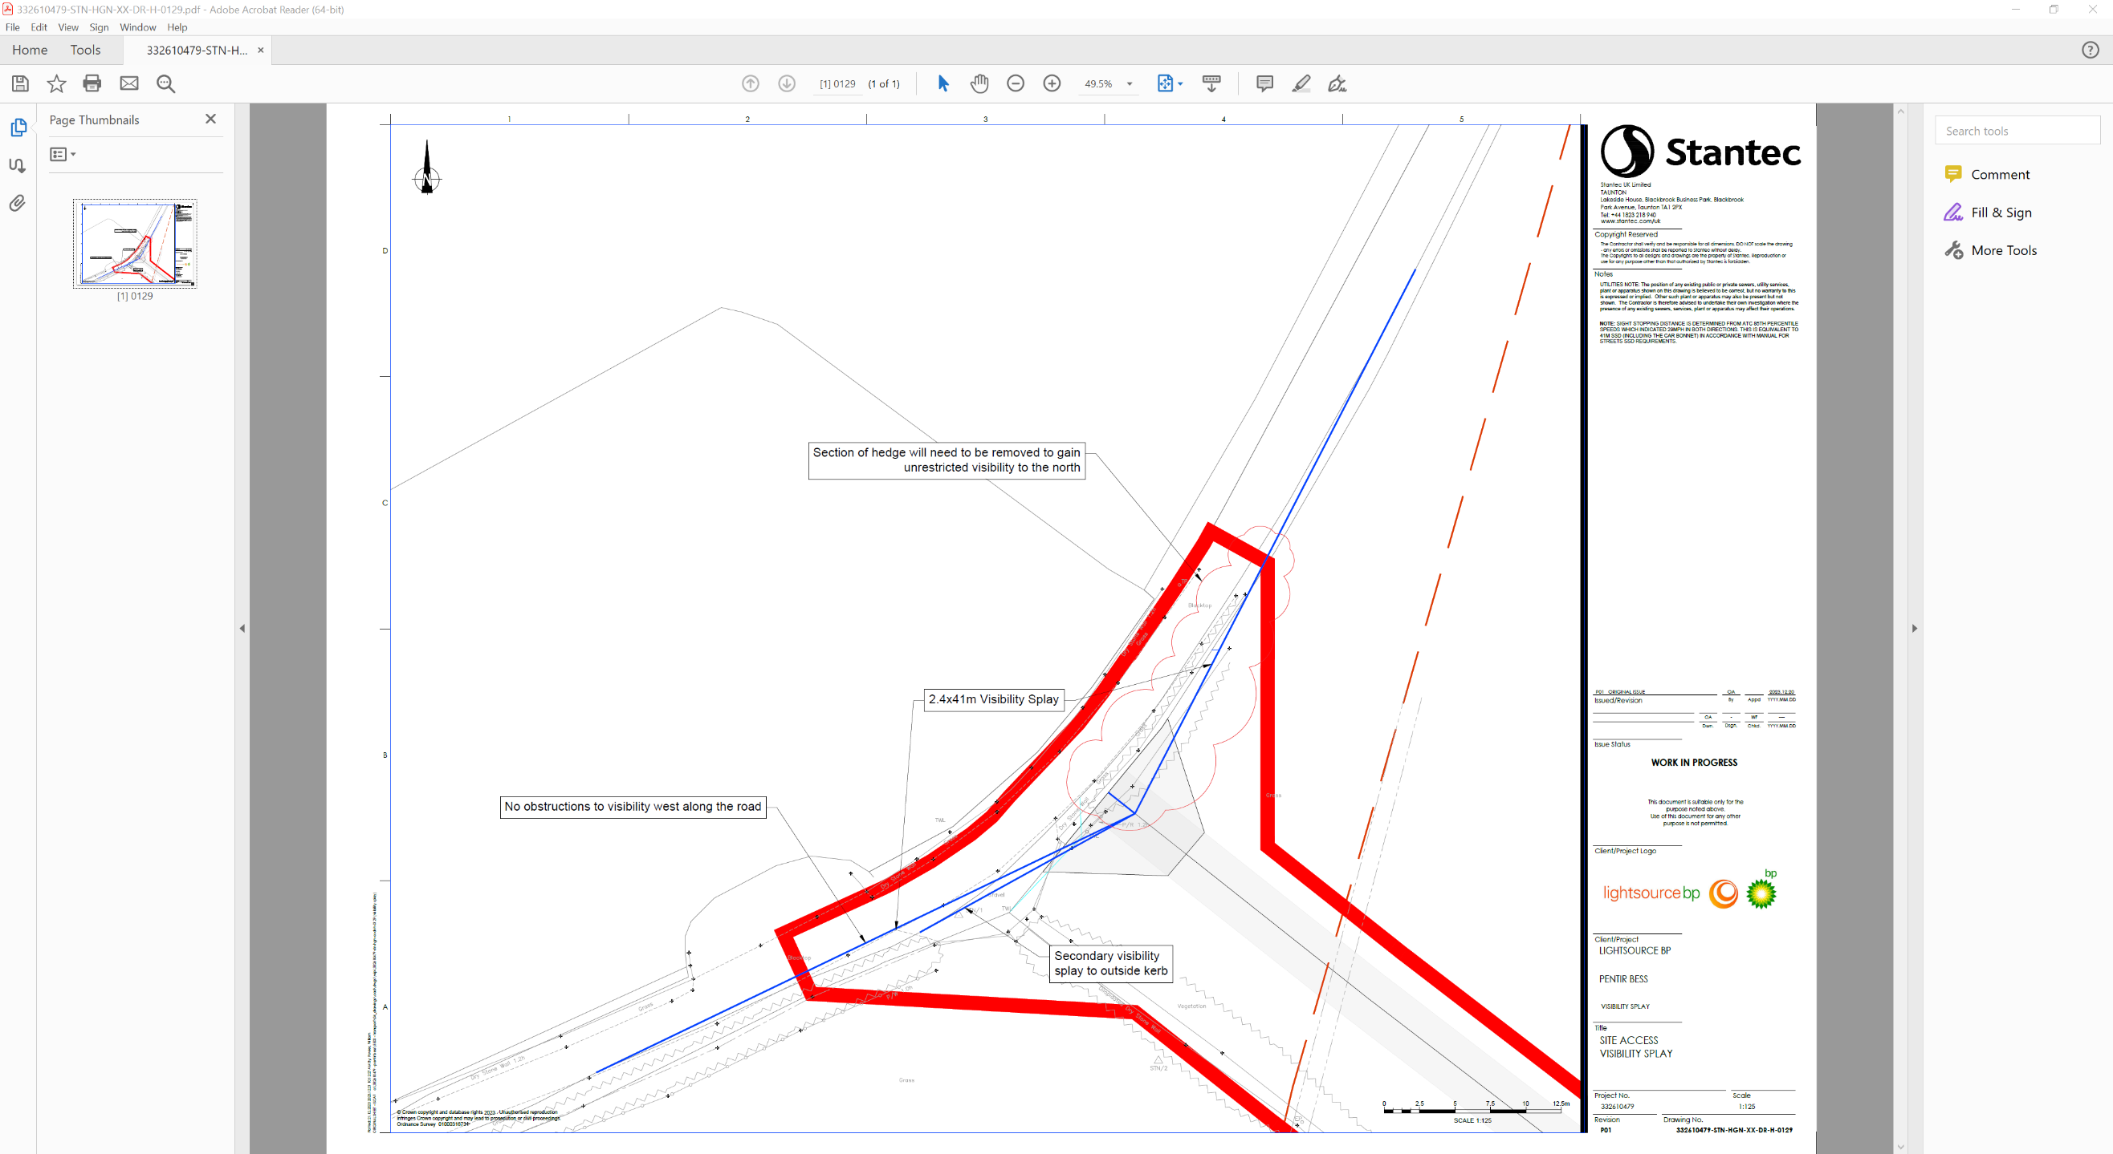
- Site Access Visibility Splay

Construction Logistics and Community Safety (CLOCS): Planned Measures (clocs.org.uk)

