Pentir Energy Storage Project
Transport Statement

Document Control Sheet
Project Name: Pentir Energy Storage Project
Project Ref: 332610479
Report Title: Transport Statement
Doc Ref: v3
Date: April 2024

 | Name | Position | Signature | Date
Prepared by: | Sophie Ripley | Graduate Transport Planner | SR | April 2024
Reviewed by: | Tim Hapgood | Associate | TH | April 2024
Approved by: | Adrian Neve | Director | AN | April 2024
For and on behalf of Stantec UK Limited

Revision | Date | Description | Prepared | Reviewed | Approved
v3 | 22/04/2024 | Update of final layout | SR | TH | AN

This report has been prepared by Stantec UK Limited (‘Stantec’) on behalf of its client to whom this report is addressed (‘Client’) in connection with the project described in this report and takes into account the Client's particular instructions and requirements. This report was prepared in accordance with the professional services appointment under which Stantec was appointed by its Client. This report is not intended for and should not be relied on by any third party (i.e. parties other than the Client). Stantec accepts no duty or responsibility (including in negligence) to any party other than the Client and disclaims all liability of any nature whatsoever to any such party in respect of this report.

Contents
1 Introduction 1
1.2 Project Description 1
1.3 Overview and Structure of Transport Statement 1
1.4 Site Context 2
1.5 Background 2
1.6 The Applicant 2
2 Policy Context 3
2.1 Introduction 3
2.2 National Policy and Guidance 3
2.3 Regional Policy and Guidance 4
2.4 Local Policy and Guidance 5
3 Baseline Conditions 6
3.1 Introduction 6
3.2 Site Location and Description 6
3.3 Existing Conditions of Local Transport Network 7
3.4 Local Highway Network Performance 9
3.5 Road Safety 17
4 Trip Generation 18
4.1 Introduction 18
4.2 Operational Trip Generation 18
4.3 Construction Trip Generation 18
4.4 Construction Worker Trip Generation 19
4.5 Decommission 19
5 Traffic Impact Analysis 20
5.2 Safety 20
5.3 Operation 20
5.4 Construction 20
5.5 Decommissioning 20
5.6 Local Developments 20
6 Access Strategy 22
6.1 Introduction 22
6.2 Access Strategy 22
8 Conclusion 24

Figures

Figure 3-1: Site location and boundary 8
Figure 3-2: Regional Site Plan 9
Figure 3-3: Public Rights of Way network around Site 11
Figure 3-4: ATC Survey Locations (Approximate) 12
Figure 3-5: ATC Location 1: Average Daily Movements (Weekday) – Eastbound and Westbound 13
Figure 3-6: ATC Location 2: Average Daily Movements (Weekday) - Eastbound and Westbound 14
Figure 3-7: ATC Location 3: Average Daily Movements (Weekday) – Northbound and Southbound 14
Figure 3-8: Average Daily Movements (Weekday) for ATC Locations 1, and 2 15
Figure 3-9: ATC Location 1: Average Movements (Weekday) by Vehicle Class 16
Figure 3-10: ATC Location 2: Average Daily Movements (Weekday) by Vehicle Class 17
Figure 3-11: ATC Location 3: Average Daily Movements (Weekday) by Vehicle Cl 17
Figure 3-12: Total Number of Daily Movements 18
Figure 3-13: Average Vehicle Speed by Time of Day (Excl. Weekends) 18
Figure 3-14: Average Vehicle Speed by Time of Day (Incl. Weekends) 19
Figure 3-15 - CrashMap Recorded Incidents: 2017 – 2021 within Study Area 19
Figure 6-1: Site Layout and Access 25

Tables
Table 3-1 - Baseline Traffic Flows - Average Weekday (24hr), Two-Way 12
Table 3-2 - Personal Injury Crash Records (5 years) within study area 19

Appendices
Appendix A Swept Path Analysis - B4547 Junction
Appendix B Swept Path Analysis - Fodolydd Lane
Appendix C Swept Path Analysis – Site Access
Appendix D Swept Path Analysis - Internal Road

This page is intentionally blank

Introduction
    - Stantec has been commissioned by Lightsource bp (the Applicant) to produce a Transport Statement (TS) in support of the development of a 57MWac Energy Storage System (ESS) (herein referred to as the ‘Proposed Development’) at Pentir, west Wales.

Project Description
    - The Proposed Development will consist of an Energy Storage System (ESS) and ancillary equipment. New means of access, welfare and temporary construction and laydowns associated with the Proposed Development will also be constructed. The Proposed Development will also include landscaping and ecological enhancement areas.
    - The main components of the Proposed Development are:
- 96 x Battery Enclosures (in 24 blocks of 4 units each);
- 3 x Twin MV Skid (each comprised of 2 x Power conversion systems and 1 x MV transformer);
- 6 x Single MV Skid (each comprised of 1 x Power conversion systems and 1 x MV transformer);
- 1 x Monitoring House;
- 1 x Backup Generator;
- 1 x Intake Substation;
- 1 x Transformer;
- 3 x Storage containers
- 1 x Welfare facility
    - The Proposed Development will not include a 33kV cable to connect the battery and associated infrastructure to the National Grid substation. The cable route will be included in a separate planning application at a later date. It is anticipated that the cable would be laid underground either via surface dug trenches of approximately 1m deep and 50cm wide and backfilled or by Horizontal Directional Drilling (HDD) as necessary.

Overview and Structure of Transport Statement
    - The TS is divided into the following chapters:
- The remainder of Chapter 1 summarises the site context, background, and Proposed Development
- Chapter 2 summarises the existing national, regional and local planning policy that informs the approach and methodology of this TS.
- Chapter 3 outlines baseline conditions on-site and existing accessibility by all modes of transport
- Chapter 4 details the methodology and results of the trip generation and distribution for the Project Period.
- Chapter 5 presents the approach taken and results of the traffic impact analysis.
- Chapter 6 outlines the strategy for accessing the site during construction and operation.
- Chapter 7 summarises and concludes the TS.
    - An outline Construction Traffic Management Plan (oCTMP) has been produced to accompany this TS and will be submitted as part of the application. The oCTMP should be read in conjunction with this document.

Site Context
    - The application site (hereby referred to as ‘the Site’) covers approximately 2.59 hectares (ha) within the Site boundary and is located wholly within the administrative boundary of Cygnor Gwynedd Council (CGC). The Site is located approximately 2km to the south of Bangor, south of A55 North Wales Expressway and north of B4547.
    - The Site comprises three on agricultural fields and partially encroaches on one field to the north. The Site internal access route borders two fields to the south and one field to the north. These agricultural fields are primarily used for pasture grazing and is bound to the east by the existing National Grid Pentir substation. To the south of the Site lies agricultural land and to the north of the Site lies an unnamed road and a small landholding. To the west of the site lies Fodolydd Lane.
    - The Site is bound by a mixture of mature woodland to the south and east and contains low hedgerows and scattered trees. The existing vegetation and local topography act as natural screening, benefiting the Site.
    - The Proposed Development will not include a cable route to connect to the existing National Grid substation. The cable route will be included in a separate planning application at a later date.

Background
    - The Site is not subject to any known planning history however it lies immediately adjacent to the existing National Grid Pentir substation. The Dinorwig to Pentir underground cable replacement project has been consented by Gwynedd Council and is expected to result in some works to the Pentir Substation. The current phase of work (as of November 2023) to remove and connect cables is expected to be completed by spring 2024. Duct and cable removal and installation on A4086 and A4244 will continue to occur periodically through 2025. Decommissioning of existing cables and carriageway resurfacing is expected to be completed by May 2026. It is expected that these works will be confined to within the operational boundary of the existing substation.
    - The Site is currently used for agricultural purposes, primarily used for pasture grazing, bound by areas of woodland (mostly conifer plantation) immediately to the east the Site, with a larger area of conifer plantation extending northwards from the Site. Elsewhere, agricultural grassland is the predominant land use in the wider surrounding area.

The Applicant
    - Lightsource bp is a UK-based global leader in solar energy production and developer of utility-scale energy storage systems. Lightsource bp’s in-house energy storage team is currently working on a 3 giga-watts (GW) pipeline of opportunities across three continents. Optimised battery storage can be integrated with large scale solar projects to increase the stability and security of supply. Lightsource bp projects are mainly in Europe and North America, and it is also investing in South America, Australia and elsewhere. Globally, Lightsource bp has developed over 8.4 (GW) of solar power and complementary ESS provision.

Policy Context

Introduction
    - This section outlines the following transport planning policies relevant to the Proposed Development, in the context of north west Wales, which have been considered in preparing this TS.

National Policy and Guidance
Future Wales: The National Plan 2040
    - Future Wales: The National Plan 2040 was published on 24th February 2021 and is a national spatial strategy that sets out where and how development should take place in Wales to address key national priorities, such as sustaining and developing a vibrant economy, achieving decarbonisation and climate resilience, developing strong ecosystems, and improving the health and wellbeing of communities.
    - Policy 17 of Future Wales refers to ‘renewable and low carbon energy and associated infrastructure’. Policy 17 confirms that the Welsh Government strongly supports the principle of developing renewable and low carbon energy from all technologies and at all scales to meet our future energy needs and that in determining planning applications for renewable and low carbon energy development, decision-makers must give significant weight to the need to meet Wales’ international commitments and target to generate 70% of consumed electricity by renewable means in 2030 in order to combat the climate emergency.
    - ​Future Wales also notes that it is vital the North of Wales plays its role in decarbonising society and supports the realisation of renewable energy, stating that there is strong potential for wind, marine and solar energy generation and Strategic and Local Development Plans should provide a framework for generation and associated infrastructure. The Welsh Government also wishes to see energy generation, storage and management play a role in supporting the regional economy in the North.
    - The Proposed Development would provide an energy storage system to support the aspirations of Policy 17. In so doing, the carefully managed transport and travel associated with the construction and operation of the Proposed Development would assist with meeting low carbon energy network. This TS sets out how that transport and travel does not have a material impact on the adjoining travel network, either during construction or operation.
Planning Policy Wales (PPW), 2021
    - Planning Policy Wales (PPW) was revised on 24 February 2021 and sets out the government’s planning policies for Wales and how these are expected to be applied.
    - Paragraphs 4.1.55 and 4.1.56 of Planning Policy Wales (Edition 11, February 2021) includes the following policy regarding Transport Assessments, which is taken here in the context of this Transport Statement:
“Transport Assessments are an important mechanism for setting out the scale of anticipated impacts a proposed development, or redevelopment, is likely to have. They assist in helping to anticipate the impacts of development so that they can be understood and catered for appropriately.
Planning applications for developments, including changes of use, falling into the categories identified in TAN 18: Transport must be accompanied by a Transport Assessment. In addition, in areas where the transport network is particularly sensitive, planning authorities should consider requiring Transport Assessments for developments which fall outside of the thresholds set out in TAN 18. Transport Assessments can be required for any proposed development if the planning authority considers that there is a justification or specific need. Transport Assessments provide the basis for negotiation on scheme details, including the level of parking, and measures to improve walking, cycling, and public transport access, as well as measures to limit or reduce levels of air and noise pollution. They should cover the transport impacts during the construction phase of the development, as well as when built and in use. Transport Assessments also provide an important basis for the preparation of Travel Plans. Further guidance on Transport Assessments and Travel Plans is contained in TAN 18.”
“Where appropriate, the applicant should prepare a travel plan including demand management measures to mitigate transport impacts.” (Paragraph 5.14.4)
“A new energy NSIP may give rise to substantial impacts on the surrounding transport infrastructure and the IPC should therefore ensure that the applicant has sought to mitigate these impacts, including during the construction phase of the development.” (Paragraph 5.14.6).
“Water-borne or rail transport is preferred over road transport at all stages of the project, where cost-effective.” (Paragraph 5.14.11).
“All large infrastructure projects are likely to generate hazardous and non-hazardous waste. The [Environment Agency’s] EA’s Environmental Permitting (EP) regime incorporates operational waste management requests for certain activities. When an applicant applies to the EA for an Environmental permit, the EA will require the application to demonstrate that processes are in place to meet all relevant EP Requirements”. (Paragraph 5.15.4).
Traffic Management Act, 2004
    - Part 2 of the Traffic Management Act sets out the responsibility of Local Traffic Authorities to manage traffic networks within their geographical area of responsibility. This includes efficient use of the highway network and the requirement to take measures to minimise contributions to traffic congestion.
    - The interface with the local roads has been analysed within this TS. The forecast number of movements associated with the construction and operational processes of the Proposed Development are shown not to generate material network operation effects and congestion. Furthermore, the access proposal is designed to provide a safe and effective interface with the adjoining Fodolydd Lane and that the junction of Fodolydd Lane is not materially impacted.

Regional Policy and Guidance
North Wales Joint Local Transport Plan (2015)
    - The Local Transport Plan (LTP) has been jointly produced by the six North Wales Local Authorities. The LTP covers a detailed programme from 2015-2020 and a framework for schemes until 2030. The LTP is a statutory document that sits alongside the Local Development Plans and other policies and plans of each of the Local Authorities.
    - Page 15 of the North Wales Joint Local Transport Plan states that
“The North Wales Local Authorities aim to remove barriers to economic growth, prosperity and well-being by delivering safe, sustainable, affordable and effective transport networks”.
    - Page 26 of the North Wales Joint Local Transport Plan comments on the use of freight, with reference to (One Wales Connecting the Nation: The Wales Freight Strategy 2008):
    - “The key objectives of the Freight Strategy (One Wales Connecting the Nation: The Wales Freight Strategy 2008) are to minimise the need for transportation of freight by encouraging local sourcing and the development of distribution networks; minimise the environmental impact of freight by encouraging modal shift from road to rail, water, and air; and make the best use of the existing infrastructure in facilitating the needs of freight. The Freight Strategy emphasises the need to ensure that transport networks within Wales are not considered in isolation”.
    - The ESS which would be used as part of the Proposed Development are specialist equipment which would be procured from a select market. This minimises the opportunity for local sourcing and sets that the containerised systems are transported for the last part of their journey by road. As part of the Proposed Development, the Applicant will consider the use of freight consolidation in construction and will look to utilise suppliers who have freight consolidation integrated into their operational structure and/or have appropriate supply facilities close to the development. It is not proposed that bespoke consolidation would be appropriate for the Proposed Development.

Local Policy and Guidance
Anglesey and Gwynedd Joint Local Development Plan (JLDP), 2011 – 2026
    - The Anglesey and Gwynedd Joint Local Development was formally adopted on 31 July 2017 and the majority of decisions on planning applications in the two Planning Authority areas are based on the contents of the Plan.
    - Policy TRA 4: Managing Transport Impacts of the JLDP provides a series of points which are relevant for consideration, including:
- Properly address the demand for travel and its impacts;
- Provide safe vehicular access to the site that does not unreasonably restrict the flow of traffic on the adjoining highway network;
- Management of conflict between modes of access, including vehicles, pedestrians, and cyclists;
- Traffic and speed management measures
- Avoid unacceptable harm to safe and efficient use and operation of the road, public transport and other movement networks and routes.
    - The policies identified above establish the importance of assessing and where appropriate mitigating the impact of the transport movements associated with both the construction and operational phases of the Proposed Development. To satisfy this policy requirement the Applicant has committed to submitting this TS and oCTMP. That evidence base indicates that the effects of transport and travel associated with the construction and operation of the Proposed Development do not generate material effects on the local transport network.

Baseline Conditions

Introduction
    - This chapter provides a detailed review of the predominant transport conditions within the vicinity of the Site. This includes the existing use of the Site, the local and strategic networks providing access to the Site and an accident data review.
    - This provides the context for the detailed analysis of the likely impact of the Proposed Development and of the potential enhancements that may be required in order deliver a development that is sustainable in transport terms.
    - This chapter considers the following elements:
- Site location and current use;
- Site access arrangements;
- Existing conditions of local transport network;
- Local highway network performance; and
- Road safety.

Site Location and Description
    - The Site is located in Pentir, approximately 2 kilometres south of Bangor, Gwynedd, west Wales. The Development is on land to the north of B4547, west of A4244 and adjacent to the existing Pentir substation and is located south of the North Wales Expressway. The closest residential areas to the Site are:
- Caerhun – approx. 2.3km north-east
- Waen-wen – approx. 2.5km north-east
- Rhiwlas – approx. 3km south-east
- Penrhosgarnedd – approx. 3km north-west
    - Larger settlements within the vicinity of the Site include Bangor (approx. 4.5km north-west and Caernarfon (approx. 9km south-west).
    - As shown in Figure 3-1 below, the Site comprises three agricultural fields east of Fodolydd Lane. To the south of the Site lies agricultural land and to the north of the Site lies an unnamed road and a small landholding. The Site’s existing land use comprises of agricultural fields, primarily used for pasture grazing, bound by areas of woodland (mostly conifer plantation).
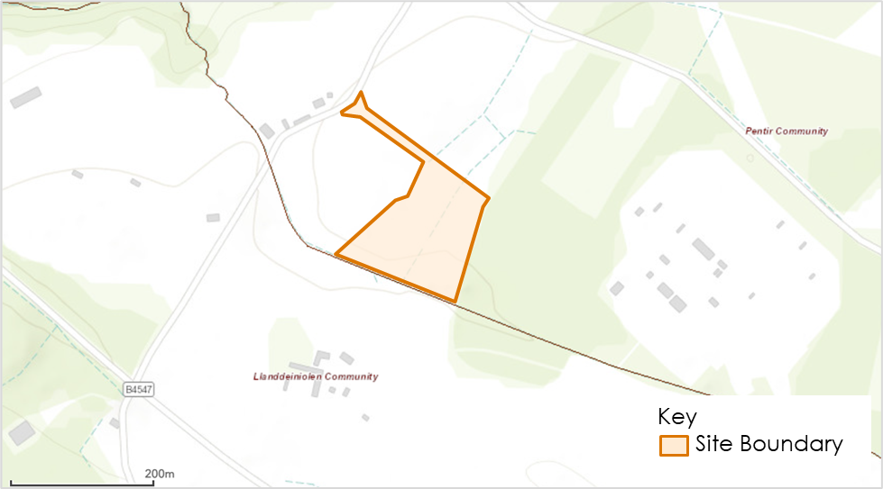
Figure 3-1: Site location and boundary
    - Figure 3-2 places the Site in a regional context and shows it in relation to locations including Holyhead, Eryri (formerly Snowdonia), Wrexham, Liverpool, and Manchester.
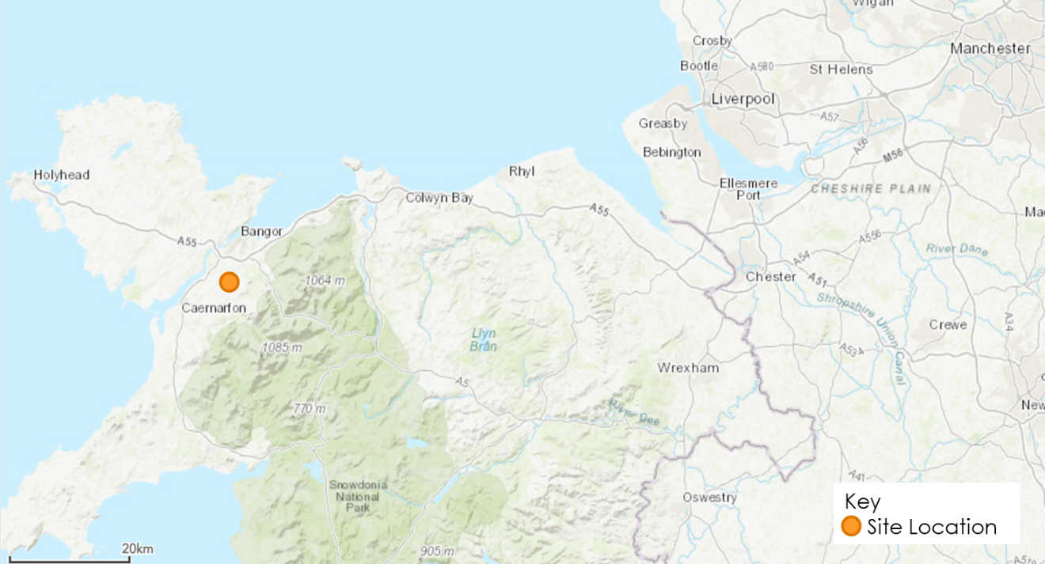
Figure 3-2: Regional Site Plan

Existing Conditions of Local Transport Network
Highway Network
    - The main strategic routes to the area near the Site are:
- National Wales Expressway (A55) towards Cheshire to the east and north Wales to the west. Other primary destinations on this route include Holyhead, Bangor, and Conwy.
- A5 towards the ferry port at Holyhead to the northwest and Birmingham to the southeast. Major road connections include M1, M6 and M6 Toll. The A5 also provides links to Shrewsbury, and Llangollen.
- A487 towards Haverfordwest, Pembrokeshire to the south and Bangor to the north. This route links to Cardigan, Aberystwyth, and Caernarfon.
    - A487 connects to A55 North Wales Expressway at Treborth Interchange. Traffic approaching the Site from A55 will travel southbound along A487 until approaching a roundabout, the traffic will travel southwest along B4547. Traffic will then turn left and travel east along B4547 before turning left onto the access road, Fodolydd Lane. A487 and B4547 are subject to the national speed limit.
    - B4547 runs south of the Site and connects to A487 approximately 1.5km to the northeast of the Site. B4547 is a 3.5km long single carriageway road with continuous road markings and a speed limit of 60mph. Much of the B4547 has a flat grass verge on either side of the carriageway but has no formal footways until the junction with Bangor Street to the west also numbered as the B4547.
    - The Site is accessible by Fodolydd Lane, the Site access is located approximately 500m along Fodolydd Lane from the B4547. Fodolydd Lane is a narrow-unmarked single-track road and is bordered by trees, hedgerows and stone walls and has no footways on either side. The road is unrestricted and has a speed limit of 60mph.
    - Other roads surrounding the Site mainly consist of rural and agricultural roads with intermittent road markings. Many of these roads are bordered by hedgerows and fencing onto agricultural land.
Public Transport – Rail
    - The nearest railway station to the development is Bangor (Gwynedd), located 7.9 kilometres away. Transport for Wales operates a service connecting to Cardiff Central; London Euston; and Birmingham International. Services from Bangor (Gwynedd) start as early as 04:53hrs running as late as 21:00hrs.
    - Bangor (Gwynedd) railway station can be accessed from the development via B4547 and A4087 Caernarfon Road.
Public Transport – Bus
    - There are limited public transport links in the immediate vicinity of the Site; the nearest bus stop is located 0.5 kilometres southwest of the development site on the B4547. Bus route S2 (operated by Gwynfor Coaches) has 3 routes. For regular weekdays, their operation hours are: (1) Bangor: 6:00 AM - 7:00 PM, (2) Gwastadnant: 7:40 AM - 5:40 PM, and (3) Llanberis: 7:00 AM - 4:17 PM.
    - Bus route 85C (operated by Dilwyn’s Coaches) runs on Sundays and Bank Holiday Mondays, running once in the morning from Deiniolen to Bangor, and once in the evening.
Cycle and Pedestrian Network
    - There are unsegregated pedestrian/cycle route facilities along the section of the B4547 towards the A487. Unsegregated pedestrian/cycle route facilities are present along the A487 towards Bangor, and the A4087. There are no other nearby dedicated or marked pedestrian/cycle paths within close proximity of the Site.
    - Due to the Site’s rural location, there is limited opportunities to walk directly to and from the Site from nearby residential areas or from public transport infrastructure. The type and nature of the Proposed Development means that walking trips are expected to be minimal.
    - There are no formal cycling infrastructure or routes within the immediate vicinity of the Site. The type and nature of the Proposed Development means that cycling trips are expected to be minimal.
Public Rights of Way (PRoW)
    - The Public Rights of Way (PRoW) network in the vicinity of the Site has been assessed. There is no PRoW within the Pentir Site boundary; therefore, there will be no diversion or extinguishment of any PROW as a result of the Proposed Development.
    - There are several PRoWs in the surrounding area of the Site as shown in Figure 3.3 below.
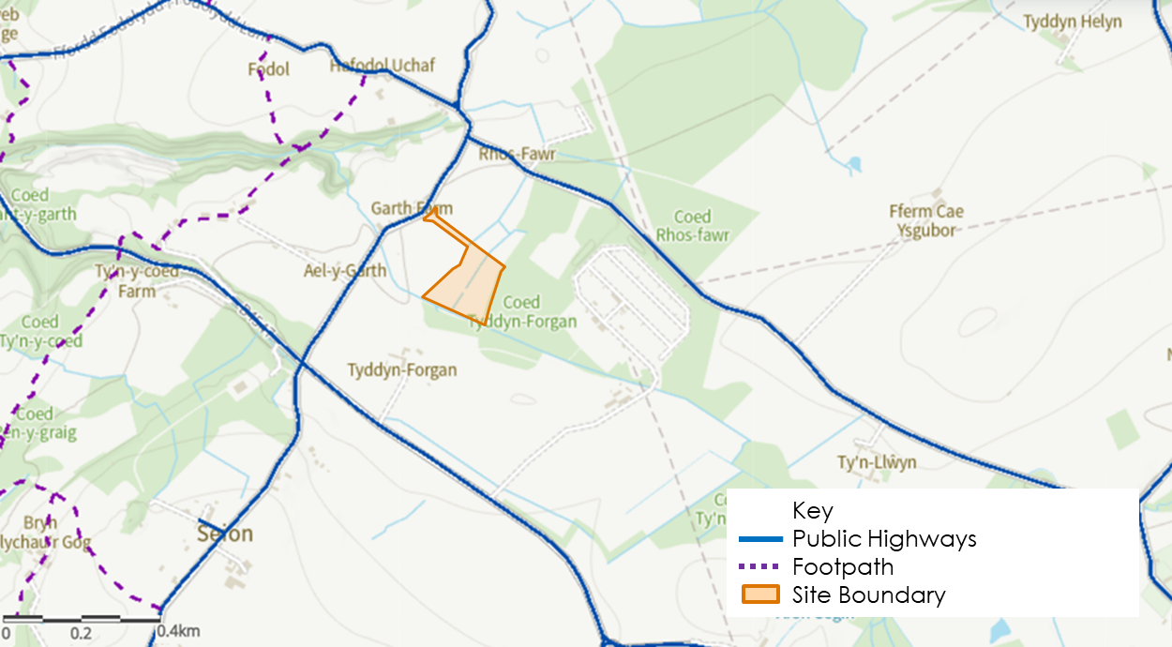
Figure 3-3: Public Rights of Way network around Site

Local Highway Network Performance
    - Automatic Traffic Count (ATC) surveys were undertaken for roads within the study area of the Proposed Development and potential access junctions. The surveys were undertaken between 06 September 2023 to 12 September 2023. The three ATC survey locations were as follows:
- ATC Location 1: B4547 west of Fodolydd Lane junction (53.186960, -4.172086)
- ATC Location 2: B4547 east of Fodolydd Lane junction (53.185111, -4.168317)
- ATC Location 3: Fodolydd Lane north of B4547 (53.188614, -4.167898)
    - A map of the Proposed Development boundary and the ATC survey locations is shown in Figure 3-4 below.

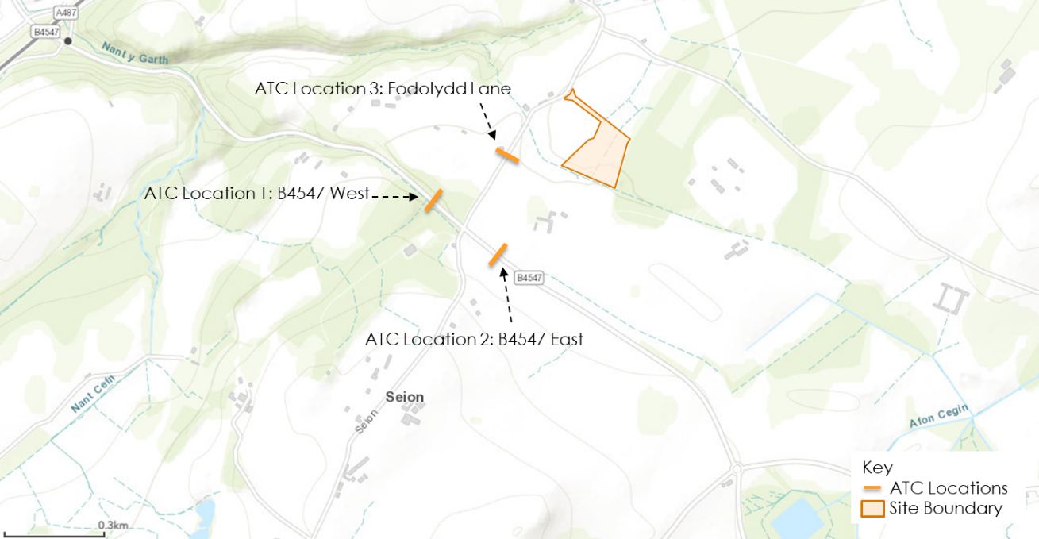
Figure 3-4: ATC Survey Locations (Approximate)
    - The average weekday two-way traffic flows for the local roads are set out in Table 3-1 below.
Table 3-1 - Baseline Traffic Flows - Average Weekday (24hr), Two-Way
ATC Survey Location | Road Section | Average Weekday (24hr) Two-Way | % HGV
1 | B4547 west | 6096 | 1.79%
2 | B4547 east | 5914 | 2.52%
3 | Fodolydd Lane | 113 | 1.42%

    - As shown, the baseline data for B4547 shows the road network flows within the vicinity of the Site are low when compared to a typical theoretical maximum capacity for a single lane of traffic in the order of 1850 passenger car units (PCUs) per hour (which could be equivalent to around 18500 PCUs per day per direction). The traffic flow on Fodolydd Lane is typically less than one or two vehicles per hour. The network is operating within theoretical capacity. This level of traffic flow identified is considered reflective of normal operating conditions and does not appear to present any specific operational challenges.
    - The average daily movements in each direction (excluding weekends) by time of day for ATC Locations 1, 2 and 3 are outlined in Figure 3-5, Figure 3-6 and Figure 3-7 below. As shown, there are clear peak periods in the morning and afternoon, roughly between 07:00 – 08:00 and 16:00 – 17:00. ATC Location 1 and 2 are the busiest of the three ATC Locations and have a similar average number of movements throughout the day due to there being very limited traffic flow turning into or out from Fodolydd Lane. The quietest location is ATC Location 3 on Fodolydd Lane. Fodolydd Lane has extremely low vehicle numbers. The average weekday number of movements on Fodolydd Lane during the peak hours is approximately 50 times less than the average weekday number of movements on B4547 (ATC Location 1 and 2) at peak times.
Figure 3-5: ATC Location 1: Average Daily Movements (Weekday) – Eastbound and Westbound
Figure 3-6: ATC Location 2: Average Daily Movements (Weekday) - Eastbound and Westbound
Figure 3-7: ATC Location 3: Average Daily Movements (Weekday) – Northbound and Southbound
    - The traffic flow for ATC Locations 1 and 2 is summarised in Figure 3.8 below. Traffic flow for ATC Location 3 is summarised in Figure 3.9 below.

Figure 3-8: Average Daily Movements (Weekday) for ATC Locations 1, and 2
Figure 3-9: Average Daily Movements (Weekday) for ATC Location 3

    - There are clear tidal flows present along ATC Locations 1 and 2, with more vehicles travelling westbound in the morning and eastbound in the afternoon. This is likely a result of commuting trips from the surrounding residential areas to areas of employment.
    - The average daily movements (excluding weekends) by vehicle class are shown in Figure 3-10, Figure 3-11, and Figure 3-12 below. As can be seen cars and Light Goods
Figure 3-10: ATC Location 1: Average Movements (Weekday) by Vehicle Class

Figure 3-11: ATC Location 2: Average Daily Movements (Weekday) by Vehicle Class

Figure 3-12: ATC Location 3: Average Daily Movements (Weekday) by Vehicle Class

    - Vehicles (LGVs) make up a significant proportion of mode share for B4547 East, B4547 West, and Fodolydd Lane.
    - The total number of daily movements by day of the week is summarised in Figure 3-13 below. As shown, the number of movements on the weekend are similar to the number of trips movements on weekdays, with fewer journeys made movements on Sundays.
Figure 3-13: Total Number of Daily Movements
    - The average vehicle speeds by time of day are outlined in Figure-14 (excluding weekends) and Figure 3-14 (including weekends) below. Excluding Fodolydd Lane (ATC Location 3), vehicle speeds on average tend to slightly increase during the night, in particular between 00:00 and 05:00. During the day, average speeds on B4547(ATC Location 1 and 2) are between 40 – 50mph, with westbound vehicles travelling at slightly higher speeds.
    - The average vehicle speed on Fodolydd Lane is 35mph with a slight increase in the evening, in particular between 20:00 and 22:00. No vehicles used Fodolydd Lane between 00:00 and 06:00 hence the lack of speed data. For both the B4547 and Fodolydd Lane the average speed levels were shown to be significantly below the speed limit. This is considered positive from a road safety perspective and helpful for vehicle movements to and from the Site.
Figure 3-14: Average Vehicle Speed by Time of Day (Excl. Weekends)
Figure 3-15: Average Vehicle Speed by Time of Day (Incl. Weekends)

Road Safety
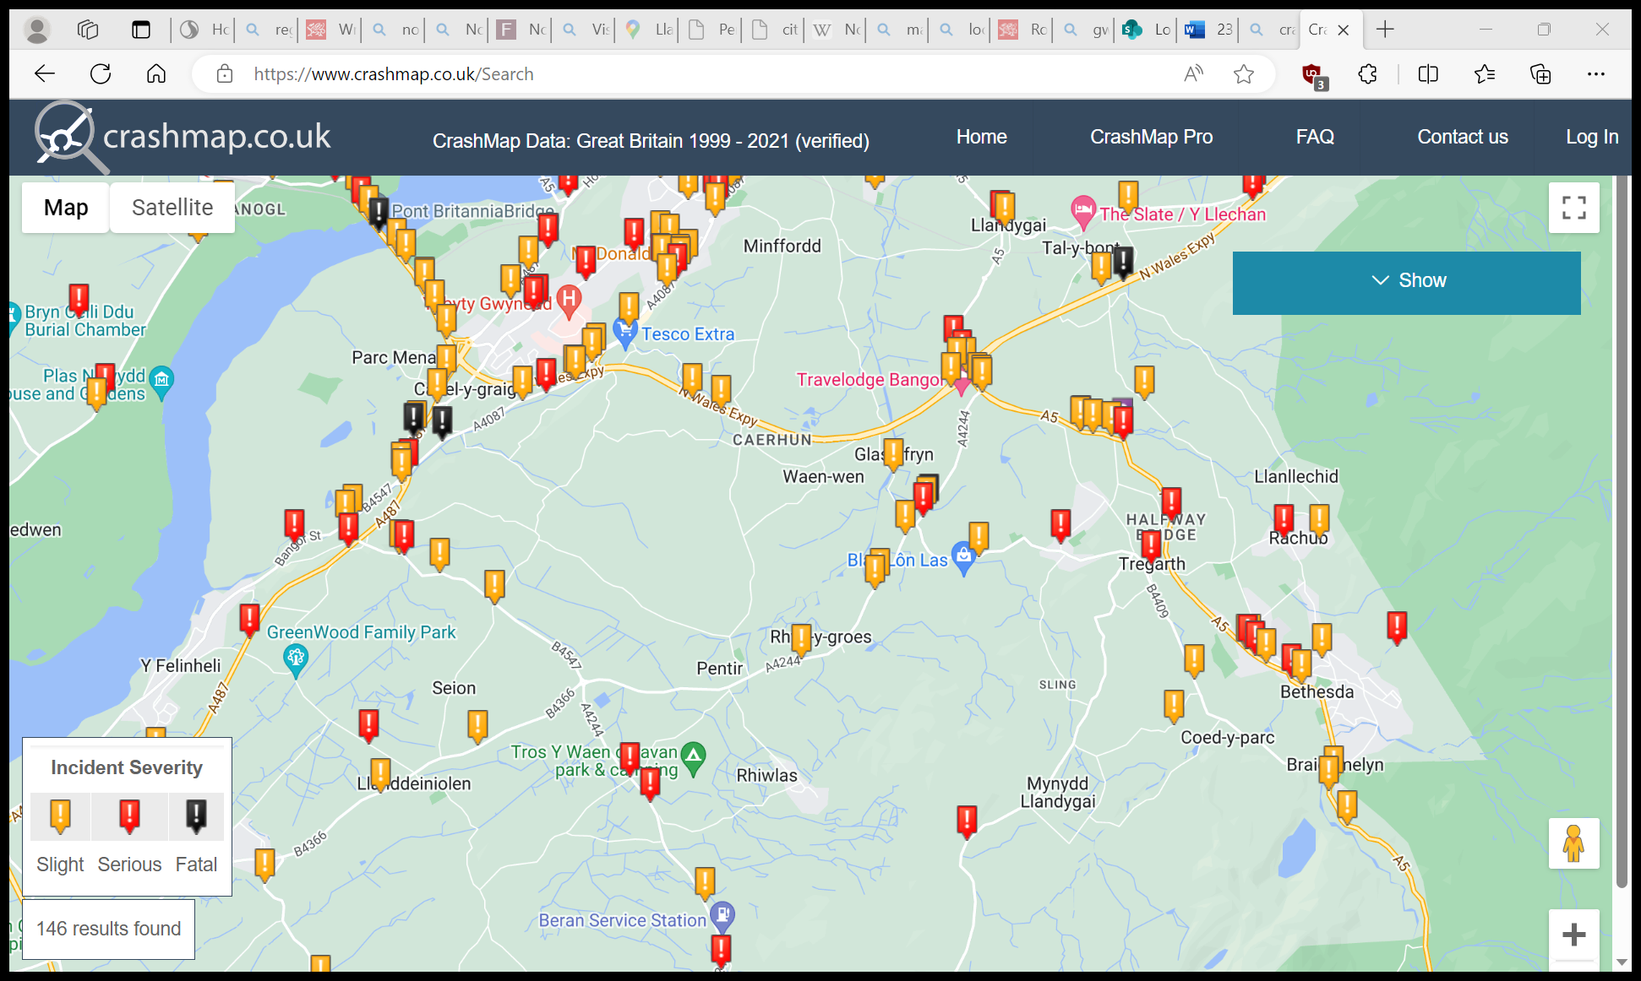
    - Road traffic collision statistical data for the road network in the study area has been obtained from the Crashmap website for the five-year period (2017-2021). As shown, the majority of recorded incidents are along the strategic road network – A487, A4087, A4244, and B457. The study area analysed for collision data is shown below in Figure 3-16.
Proposed Development
Figure 3-16 - CrashMap Recorded Incidents: 2017 – 2021 within Study Area
Source: www.crashmap.co.uk. Data Source: DfT Road Safety Data. Background map: Google
    - The study area, as shown in Figure 3-16, is approximately 20km square and consists of the road network in proximity to the Site, including B4547, A487 and National Expressway. Table 3-2 below summarises the accident data within the study area.
Table 3-2 - Personal Injury Crash Records (5 years) within study area
Total Collisions | % Slight | % Serious | % Fatal
26 | 69% | 23% | 8%

    - It should be noted that on the B4547 only four accidents (3 slight, 1 serious) were recorded during the five-year period and no accidents on Fodolydd Lane. This indicates there is no notable safety concern related to the local road network or site access.

Trip Generation

Introduction
    - Trip generation for construction, operation and decommissioning of the Proposed Development has been undertaken using a first principles approach based on information supplied by the Applicant and professional judgement regarding transport and logistics requirements for the site.

Operational Trip Generation
    - Once operational, the Proposed Development will be monitored remotely and will not require any permanent staff to be located on-site. Occasional maintenance activities will be required, typically for equipment maintenance and ESS upkeep. This would equate to approximately 2 – 4 per month. No formal on-site parking spaces are proposed as maintenance visits can be accommodated informally within the curtilage of the Site. There is sufficient space within the curtilage of the Site to ensure that maintenance vehicles will be able to enter and leave the Site in a forward gear.
    - Maintenance visits will typically be undertaken using a Light Goods Vehicle (LGV) or a four-wheel drive vehicle with 1 – 2 operational staff. Occasionally a larger vehicle such as a rigid HGV may be needed for maintenance when there is a need to replace equipment. To facilitate this, the permanent site access has been designed to accommodate a large HGV – vehicle swept path analysis for 16.5m artic can be found in Appendices A and B.
    - Swept path analysis has also been undertaken for a fire tender showing the vehicle entering the Site, manoeuvring safely around the internal road network, and exiting in forward gear. The swept path plan is included in Appendix D.

Construction Trip Generation
    - It is expected that a range of construction vehicle types would access the Site to enable construction of the Proposed Development. These include but are not limited to the following:
- Light Goods Vehicles (LGVs) i.e., vans and small flatbeds – movements for plant maintenance, PPE, fixings/small components, sundry items, canteen supplies, couriers, post/parcels;
- Heavy Goods Vehicles (HGVs) i.e., 2-6 axle rigid or articulated lorries and mobile cranes - movements of materials/component deliveries, plant deliveries, spoil removal, concrete, aggregate supplies, cabling, containerised equipment, fencing etc;
    - Abnormal indivisible loads are not anticipated to be required.
    - The Applicant has indicated based on previous experience that the construction works during the enabling and civil works (Phases 1 and 2) could require up to 10 HGV deliveries (20 movements) per day, including concrete deliveries. However, this number of deliveries is unlikely to be required every day during this period.
    - During delivery of the ESS and associated equipment (Phase 3), the Applicant has indicated that around 10 – 15 deliveries (20 – 30 movements) could be required over a period of 3 – 4 days. Significantly less deliveries would then occur on a daily basis over the remaining duration of Phase 3.
    - During the latter phases of the construction (Phases 4 and 5), which would involve commissioning and demobilisation followed by landscaping work, the Applicant has indicated that there would be limited HGV movements. The works required would be carried out by individual personnel doing electrical and commissioning work over a period of 3 – 4 months.
    - It is recognised that a flat profile across the programme is unlikely and there will be peaks in activity associated with overlaps in the construction programme and more transport intensive activities taking place.
    - An initial construction vehicle movement profile has been developed in Section 6 of the outline Construction Traffic Management Plan and should be referenced for further detail.

Construction Worker Trip Generation
    - It is estimated that there will be a maximum of approximately 30 – 40 people on the Site per day. The number of staff on Site will vary subject to the overall programme of works.
    - It is likely, based on the rural nature of the Site, that most construction workers will drive to the SIte, and it is estimated, based on previous project experience, that around 1/3 (33%) of construction workers would car share. It is considered reasonable to apply this car share mode split to the Proposed Development. It is also important to note that some workers will travel to the Site in work vans which will account for a combined staff and construction vehicle trip, this will reduce the number of vehicles travelling to Site.
    - It is anticipated that construction staff will be locally based where reasonably practicable and would likely arrive at the Site via the A5 and A55 or using the A487 travelling northbound. Workers will arrive at site between 07:00 – 08:00 therefore missing the AM network peak hour.
    - It is expected that workers will leave the Site across the afternoon period depending on their working hours and the activities taking place on site. Therefore, the departure profile will be dispersed across several hours.

Decommission
    - The energy storage project is a temporary and fully reversible, with equipment removed from site at the end of the installation’s operational life (approximately 40 years).
    - The proposed ESS is expected to have a lifespan of typically 15-20 years with total planning lifetime of 40 years. Extension of its operation beyond this timescale lifetime will be dependent on prevailing market conditions. The assets, if in continuing use, would be upgraded and follow any necessary approvals process in place at that time. The installation of the equipment will be designed in a way that it could be decommissioned and deconstructed non-intrusively due to the above ground nature of the development.
    - Should the Proposed Development be decommissioned, all above ground structures would be removed from the site, with the maximum value being recovered from materials and equipment via re-use or recycling at the time. The decision on how much of the below ground infrastructure (including foundations and concrete pads) would be retained would be agreed with the landowner and any other interested parties, accounting for decommissioning methods and timescales at the time.
    - The number of vehicle movements associated with the decommissioning phase is not anticipated to exceed that set out for the construction phase. In terms of vehicle trip generation, it is anticipated that the decommissioning method would be similar to construction but in reverse. Therefore, similar vehicles numbers are anticipated subject to changes in technology and construction techniques.

Traffic Impact Analysis
    - This section considers the impact on the road network during the construction and operation of the Proposed Development

Safety
    - The road safety data for years 2017-2021 has been obtained and analysed. As noted in Section 3.5, there are no notable safety concerns relating to the Fodolydd Lane and B4547within the vicinity of the Proposed Development.

Operation
    - As noted in the previous section once operational the development will only require occasional maintenance activities. This would equate to approximately 2 – 4 visits per month. On this basis the vehicle movements associated with the maintenance visits to the site would have an imperceptible impact on the highway network and would be considerably less than daily variation in traffic flows. Maintenance visits would still be timed to avoid network peak hours.

Construction
    - During the construction phase it is anticipated that the likely maximum number of construction vehicle trips on a single day could be between approximately 10-15 HGV trips (20-30 movements). As stated above it is estimated that a maximum of 30 - 40 staff will be on site at any one time.
    - The construction vehicle trips (HGVs and LGVs) will be spread across the day and through delivery scheduling will seek to avoid the network peak hours wherever possible. The working hours for the construction phase will be 07:00 to 19:00 Monday to Friday, 07:00 to 13:00 hours on Saturday. Therefore, the workforce will arrive at Site prior to the AM network peak and will depart across the day depending on site activity and their scheduled working hours.
    - Based on the trip generation figures presented for the construction phase and the management measures being proposed it is considered that the impact on the highway network will be negligible. The oCTMP produced to accompany this TS will be the primary control document for the construction phase. It is anticipated that a detailed CTMP will be submitted and agreed prior to commencement of the works on-site. A summary of the key points of the framework for the detailed CTMP is provided in Section 7.

Decommissioning
    - The decommissioning phase is anticipated to be similar to the construction phase, but in reverse. As such, similar impacts are anticipated subject to changes in technology and construction techniques.

Local Developments
    - No planning applications have been listed by Gwynedd Council within the vicinity of the Site that would coincide with the Proposed Development.
    - As stated previously in the TS, the Dinorwig to Pentir underground cable replacement project has been consented by Gwynedd Council and is expected to result in some works to the Pentir Substation. These works do not need to be assessed within the TS as they occur on roads not included within the vehicle routeing plan for the Proposed Development. These works also are relatively contained and have a limited impact on the road network. Due to the nature of the ducting and cable pulling work, the stretches of roads required to manage traffic will be relatively short and associated equipment will be stored in specified work areas. The installation of the new cables will be in one side of the carriageway along the A4086 and A4244 and therefore one lane can be kept open and temporary traffic lights can be used to keep traffic moving.

Access Strategy

Introduction
    - This section considers the approach to Site access for the Proposed Development in the construction, operational and decommissioning phases of the development.

Access Strategy
    - Figure 6-1 below outlines the Site access, which is detailed further below.
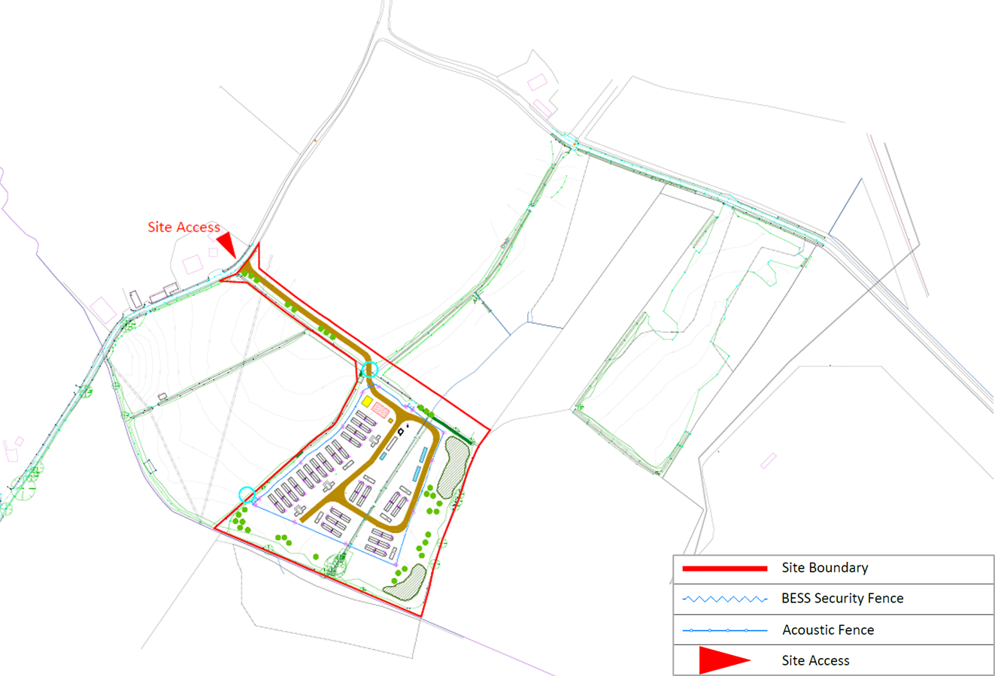
Figure 6-1: Site Layout and Access
    - This point of access would require construction of a new access route from the Pentir ESS Site onto Fodolydd Lane. It is proposed that this access is initially created to provide access for the construction phase and then retained as a permanent access for maintenance.
    - Vehicle swept path analysis for the Site access from Fodolydd Lane can be found in Appendix C.
Internal Access
    - New internal access tracks will be formed, using a layer of permeable crushed stone. Geosynthetic reinforcement or soil stabilisation may be used to reduce the depth of track construction. The surface will be a compacted granular material (crushed rock) up to an approximate thickness of 0.3m, dependent on the ground conditions. Width will increase at bends and at the entrance point. The tracks will typically measure between 3.5m and 4.5m wide.

- Construction Traffic Management Plan
    - To help manage construction vehicle and staff movements an outline Construction Traffic Management Plan (oCTMP) has been produced. A summary of the headlines of the oCTMP is provided below.
    - The construction of the Proposed Development is estimated to take approximately 12 months and will consist of the following (but not limited to) principal activities:
- Site establishment and enabling works
- Installation of construction facilities, security, and internal access tracks
- Deliveries and installation of ESS equipment and foundations
- Commissioning, demobilisation, and equipment removal
- Landscaping and biodiversity enhancements
    - The oCTMP provides a framework for management of construction vehicles associated with the development. It is anticipated that a detailed CTMP will be produced once a Principal Contractor has been appointed. The oCTMP has been produced utilising best practice and guidance including the Transport for London (TfL) Construction Logistics Planning Guidance v1.2 (April 2021) and includes the following sections:
- Context, considerations, and challenges – provides an overview of the site, nature, location and size, public transport, and walking / cycling access.
- Construction programme and methodology - provides information on the construction programme, stages, and methods of construction.
- Vehicle routeing and site access – provides details on strategic and local vehicle routes for construction vehicle movements and site access / egress arrangements.
- Strategies to reduce impacts – outlines the planned measures that will be used and indicates how construction vehicles will be managed to / from and on-site.
- Estimated vehicle movements – provides a construction vehicle trip generation profile for the duration of the construction programme.
- Implementing, monitoring, and updating – identifies how the implementation of the detailed CTMP will be monitored and managed.
    - The oCTMP sets out the measures to be implemented to manage construction vehicles and deliveries; encourage sustainable freight; and manage material procurement. The following list includes some of the measures the Applicant is committed or receptive to:
- To manage construction vehicles and deliveries the oCTMP sets out the Applicant’s commitments to adhering to vehicle safety and environmental standards and programmes, such as FORS and CLOCS; and adhering to the designated routes.
- The Applicant is receptive to potential Design for Manufacture and Assembly (DfMA) and off-site manufacturing; reuse of material on Site; and smart procurement.
- The Applicant will consider working with other construction site contractors in the vicinity off the Site, for example, the National Grid Dinorwig to Pentir underground cable replacement project.

Conclusion
    - Stantec UK PLC has been commissioned by Lightsource bp to prepare a Transport Statement in support of the development of a 57WMac Energy Storage System (ESS) at Pentir, west Wales.
    - The Proposed Development is considered to be well placed to take advantage of the surrounding transport network including good connections to the A55 National Wales Expressway.
    - The vehicle trip generation associated with the Proposed Development during construction and operation will be limited, and as such, it is considered that the development proposals can be accommodated without detriment to the local road network during construction, operation, and decommissioning.
    - The oCTMP produced demonstrates that adequate arrangements can be put in place to minimise and manage the associated environmental and traffic impacts from the construction phase of the Proposed Development.

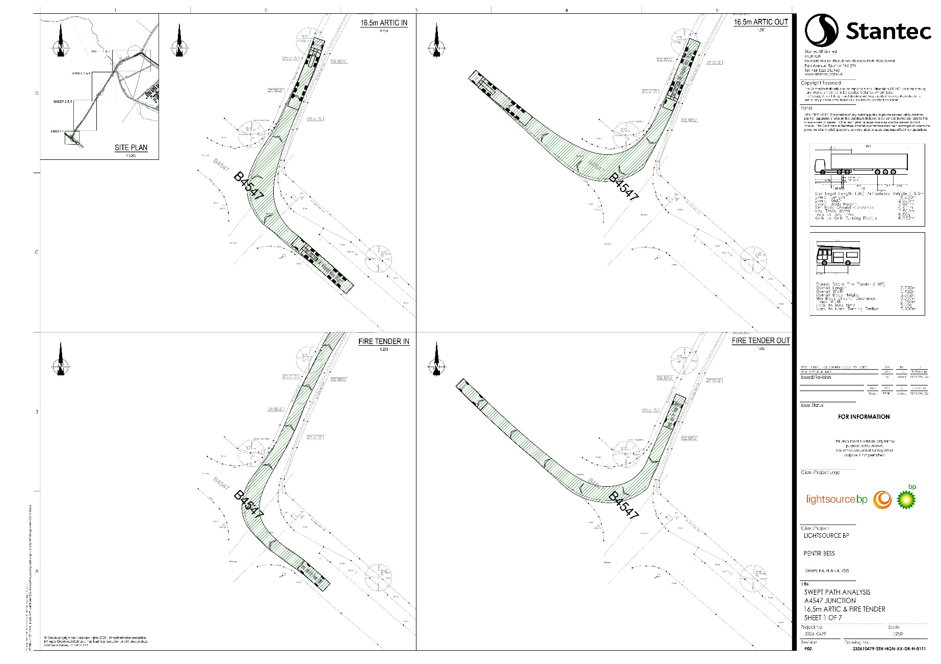
- Swept Path Analysis - B4547 Junction

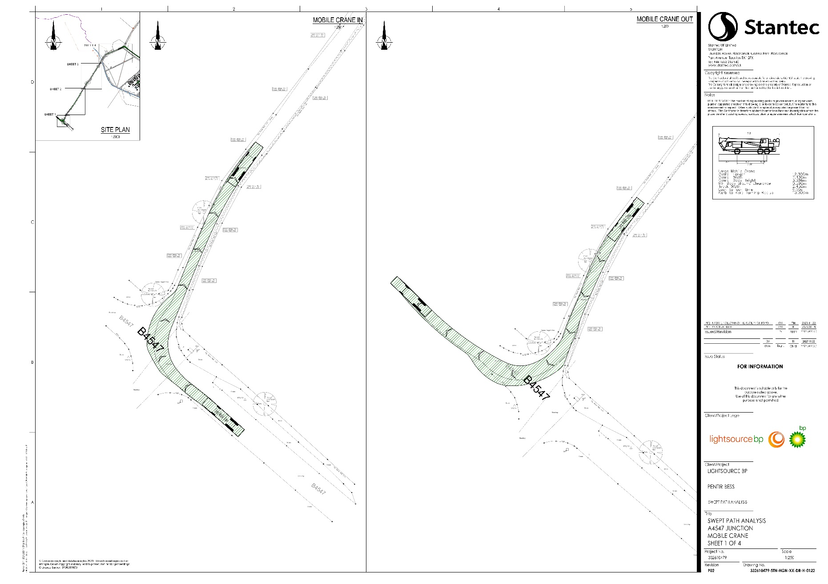
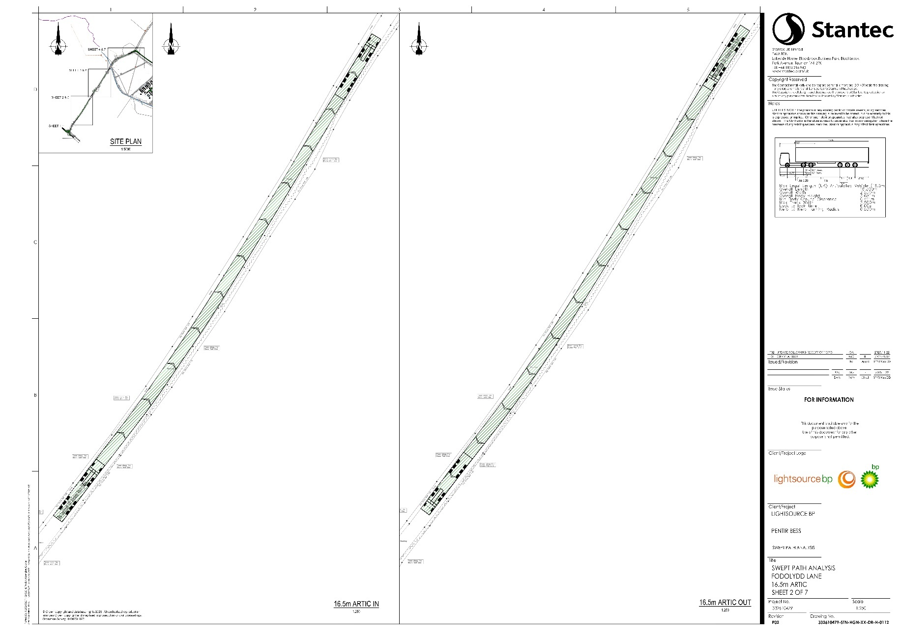
- Swept Path Analysis - Fodolydd Lane

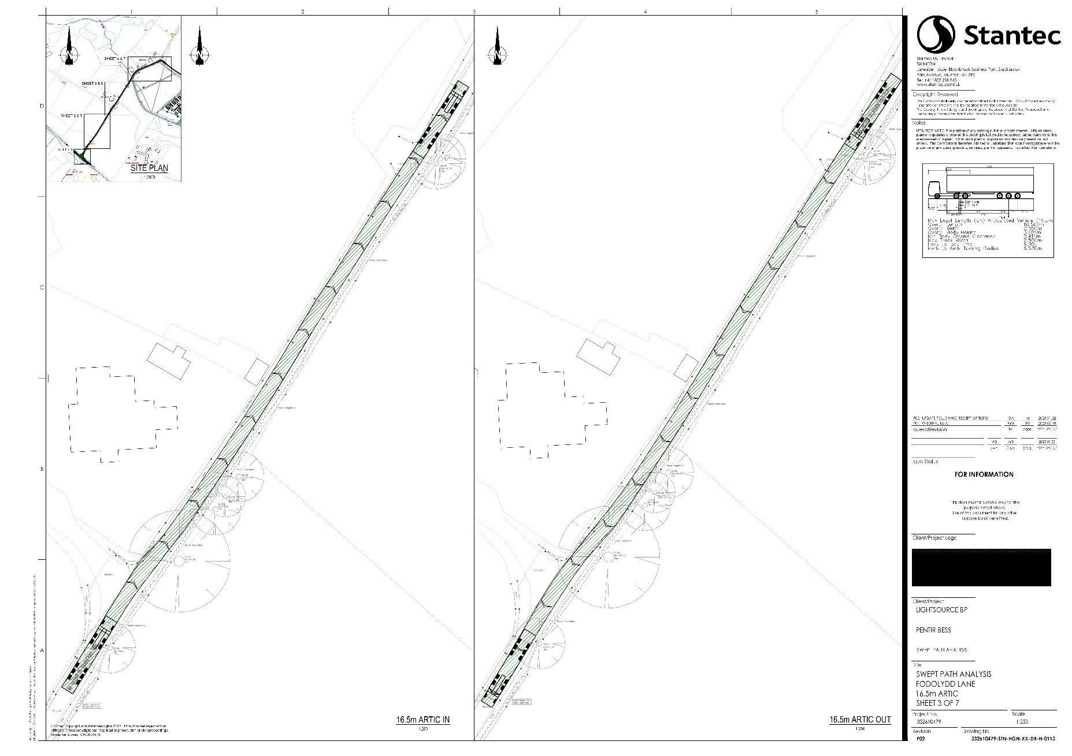
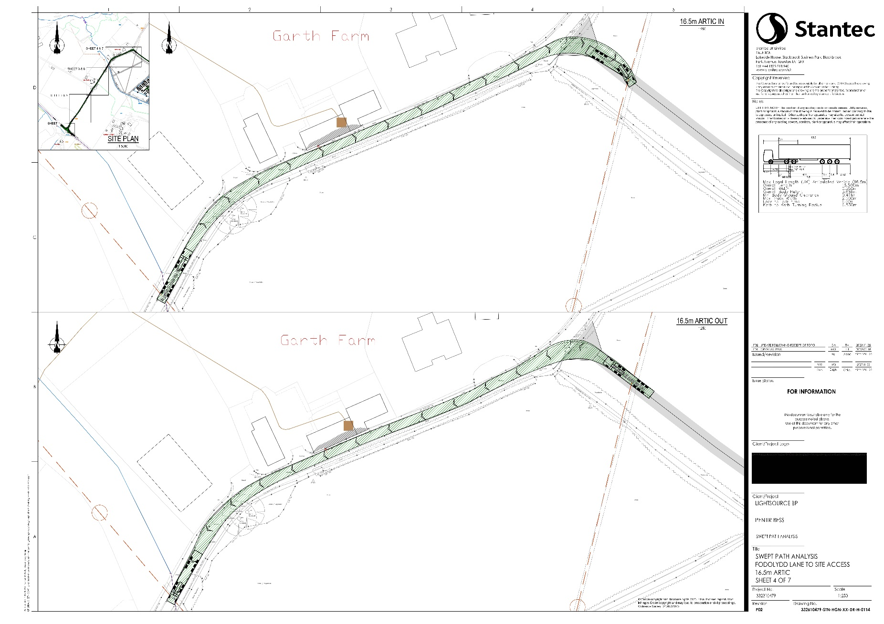

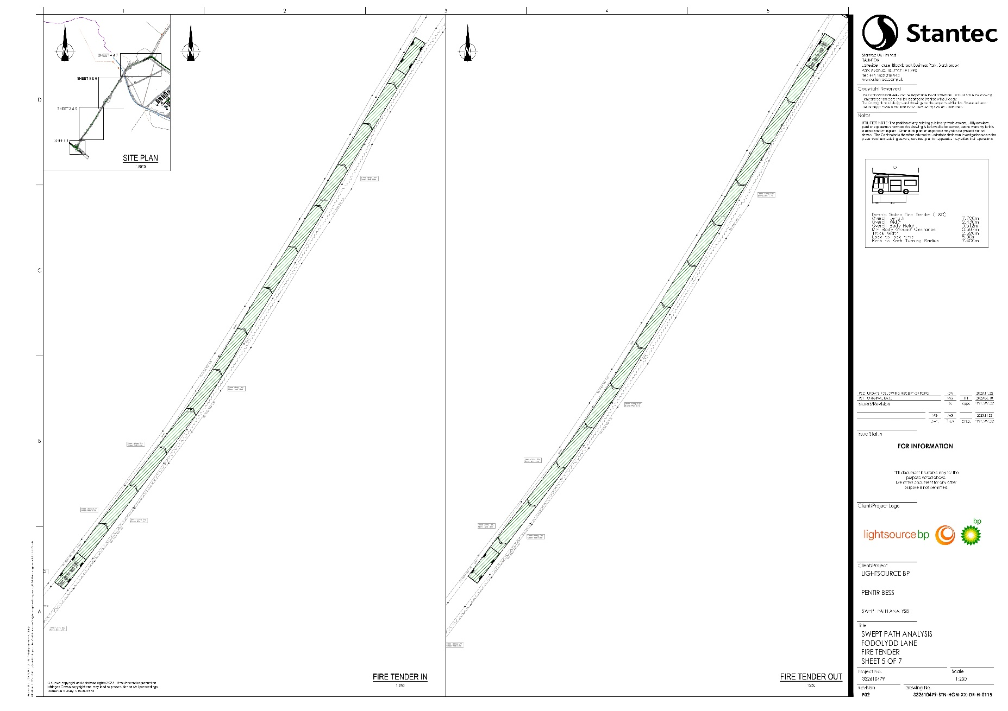
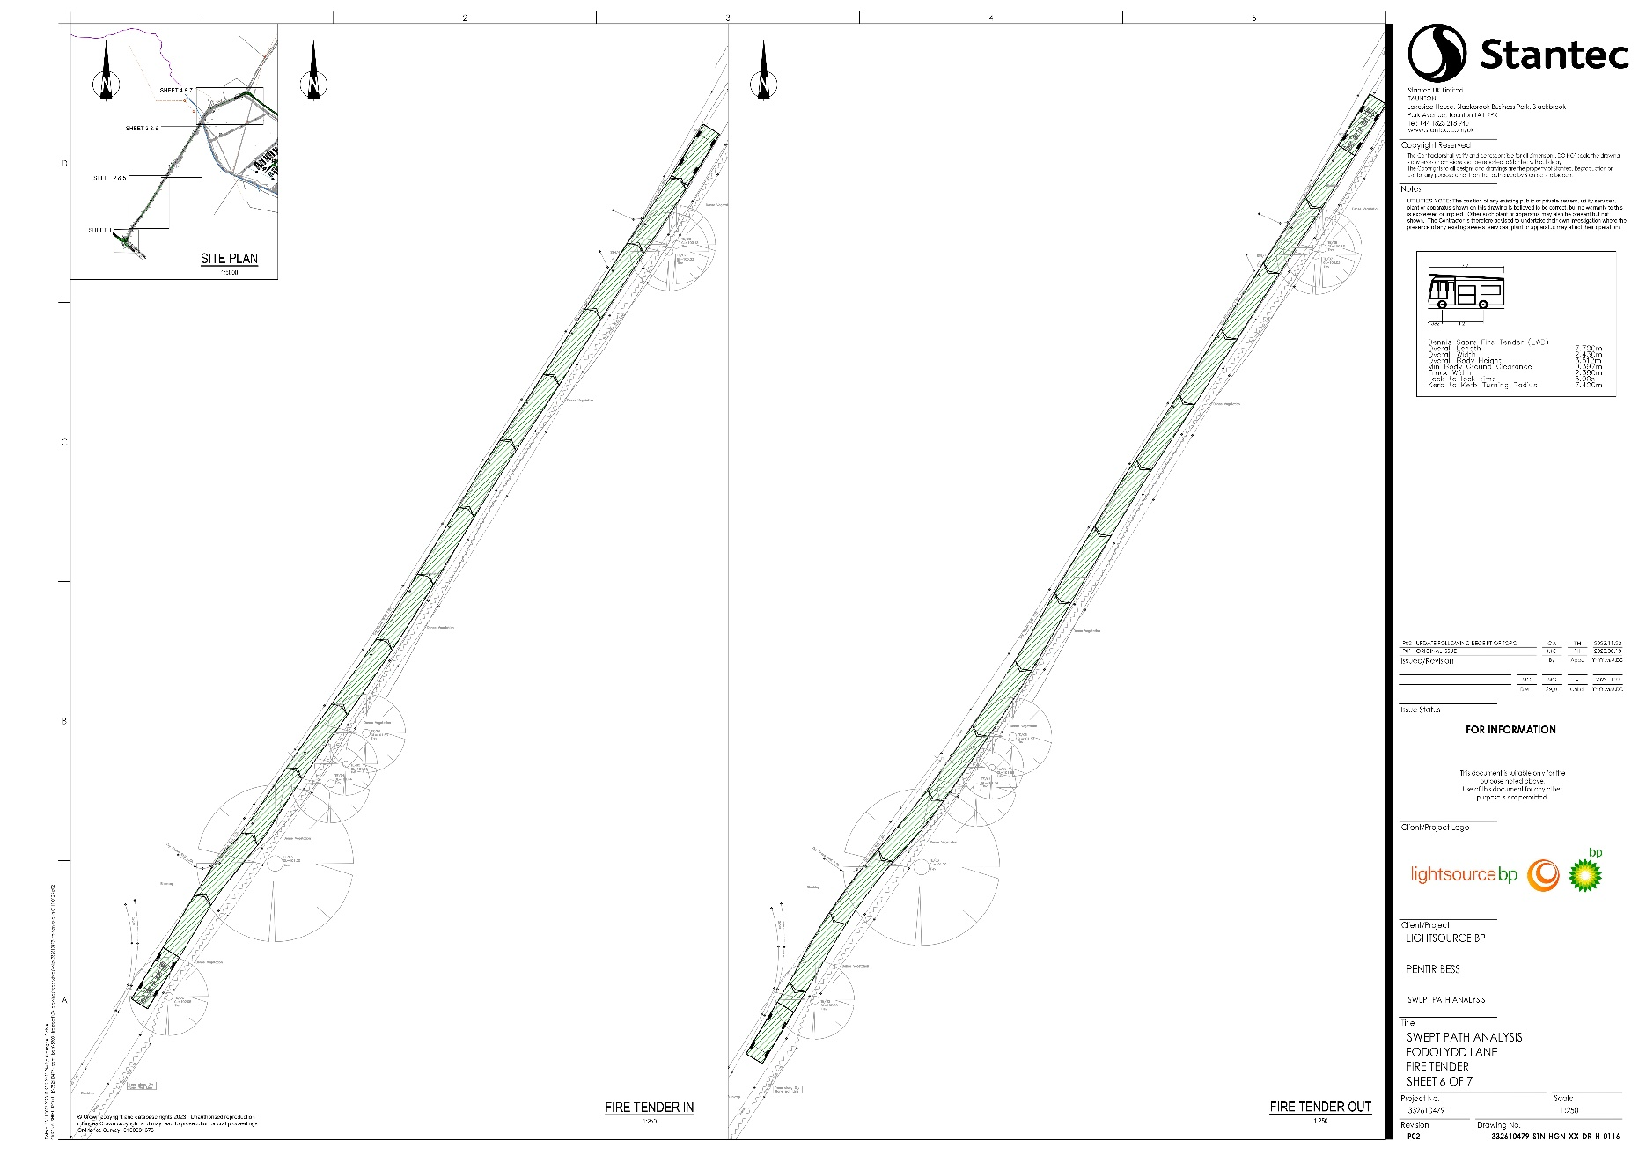
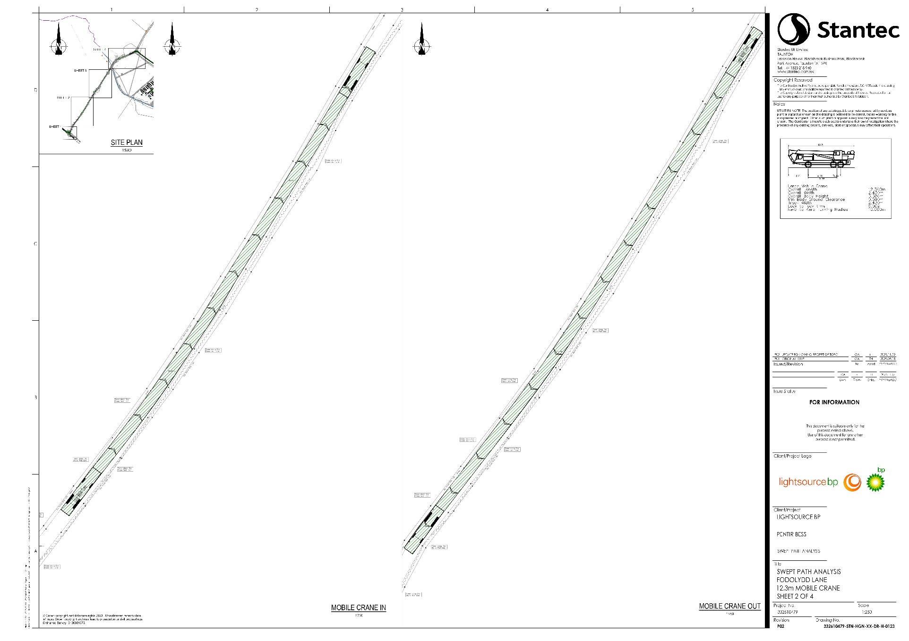
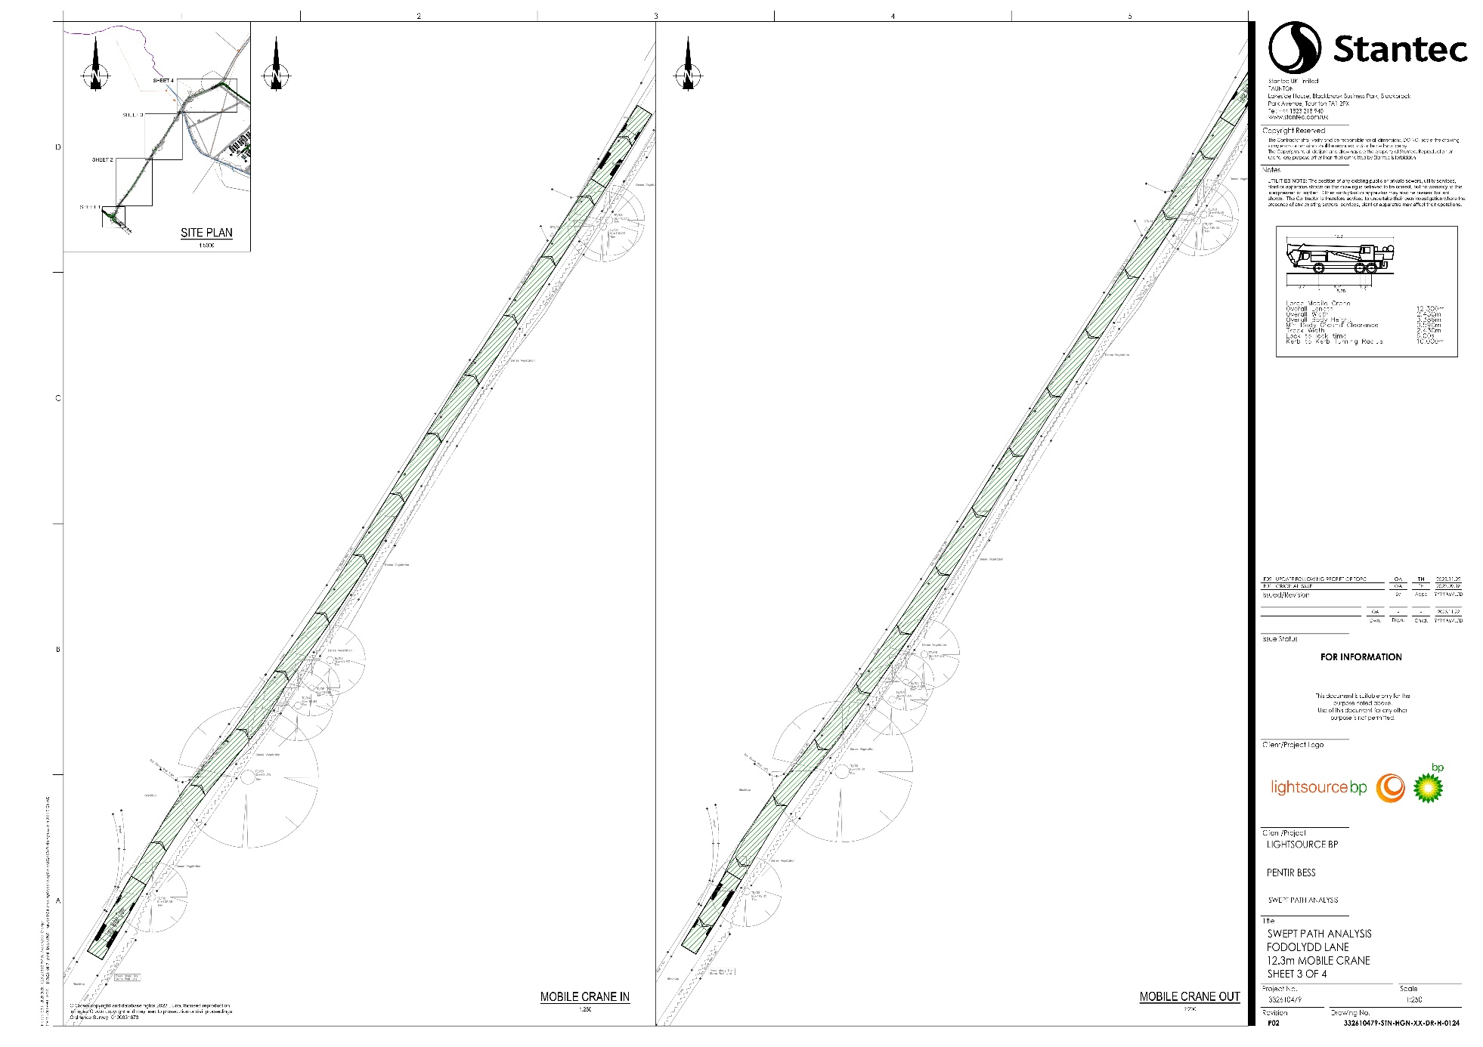
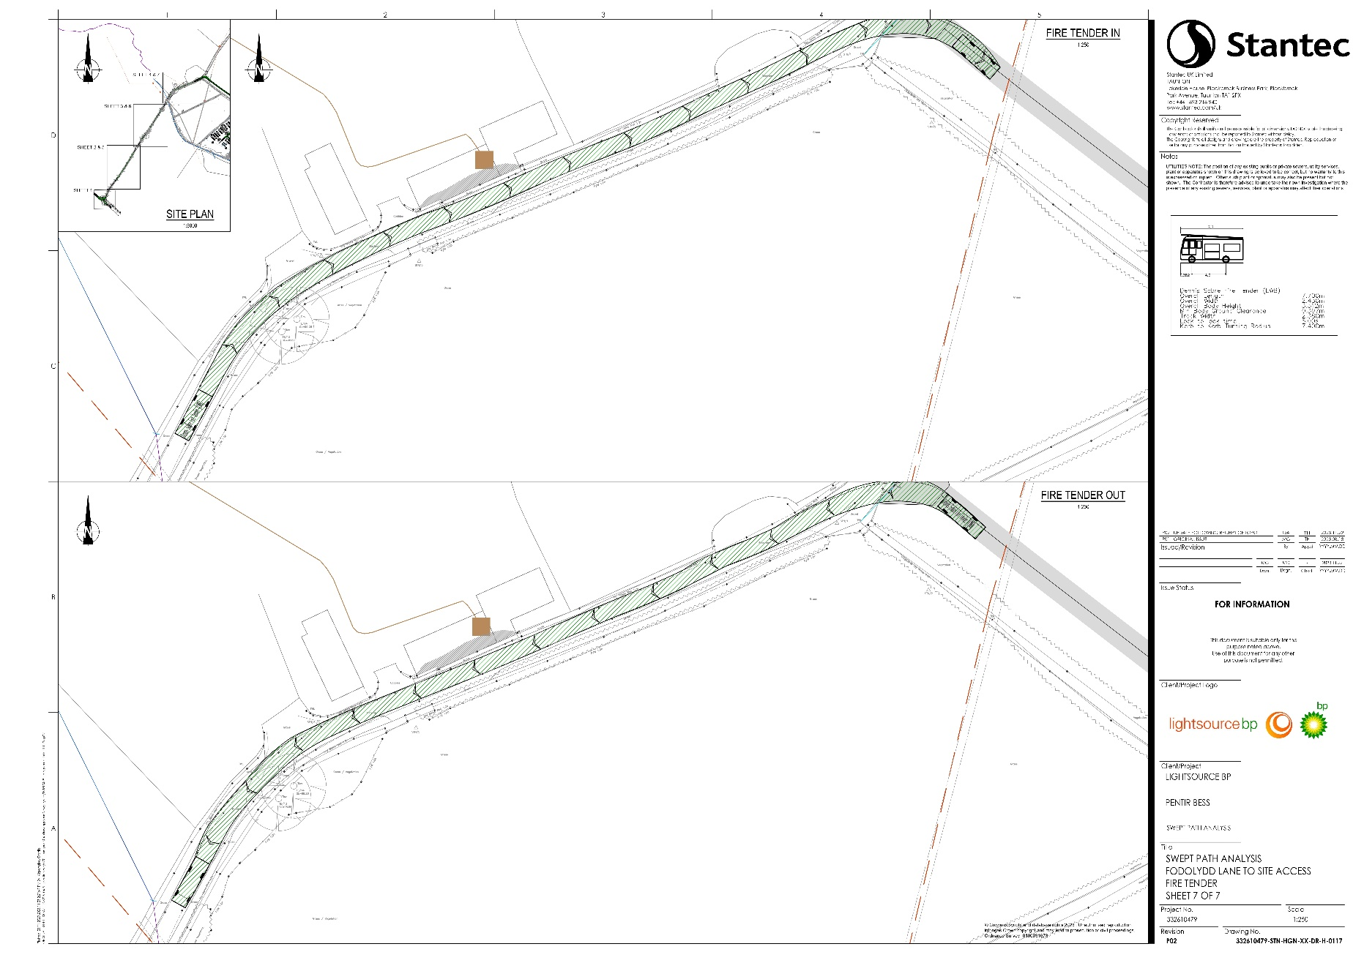
- Swept Path Analysis – Site Access

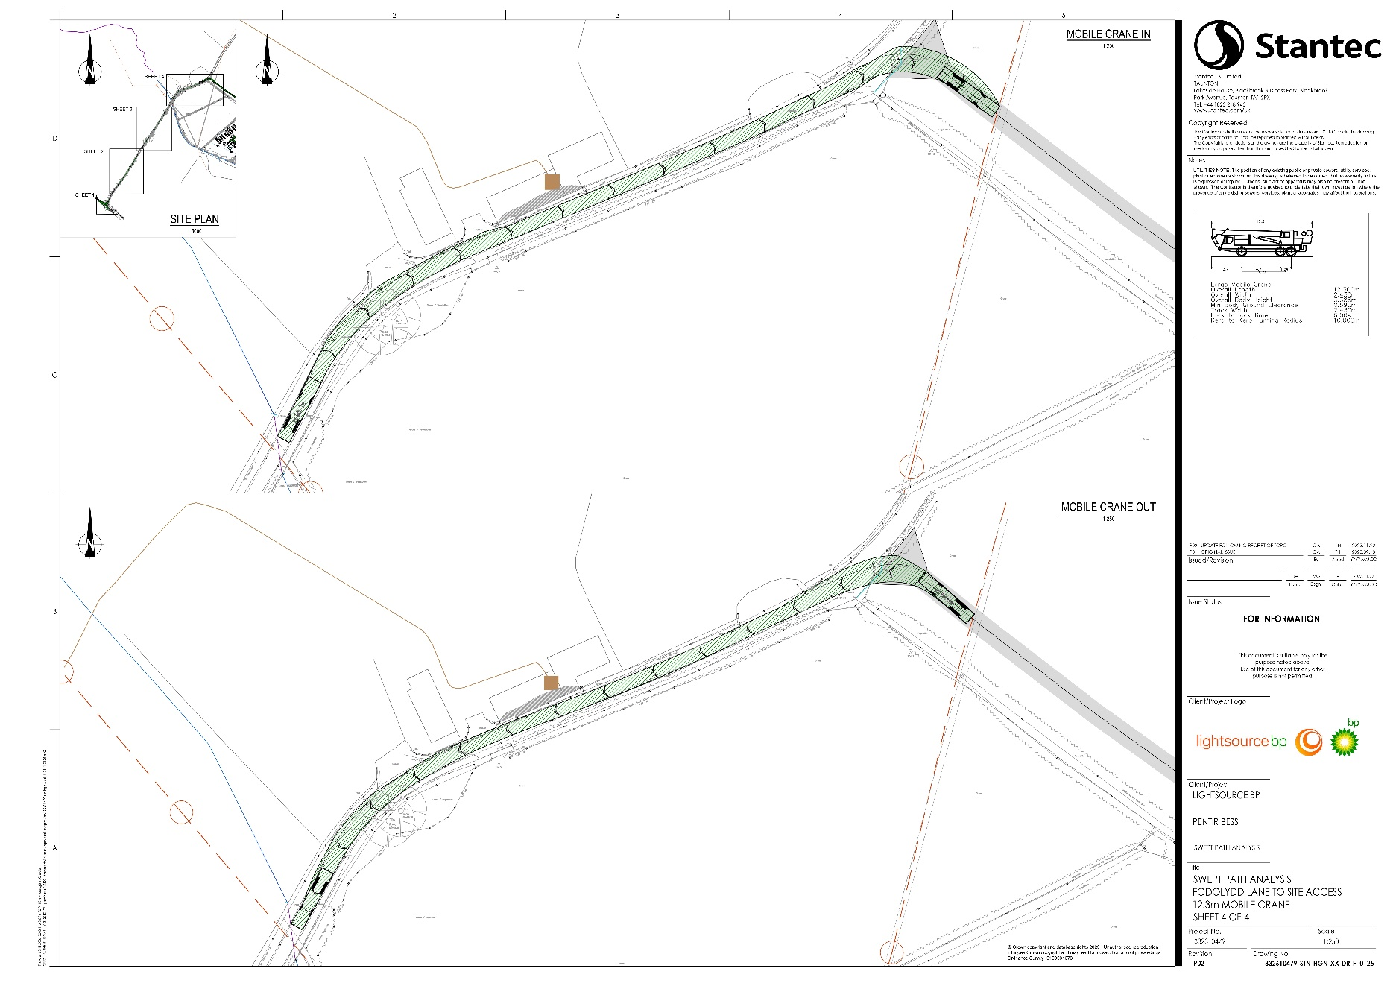
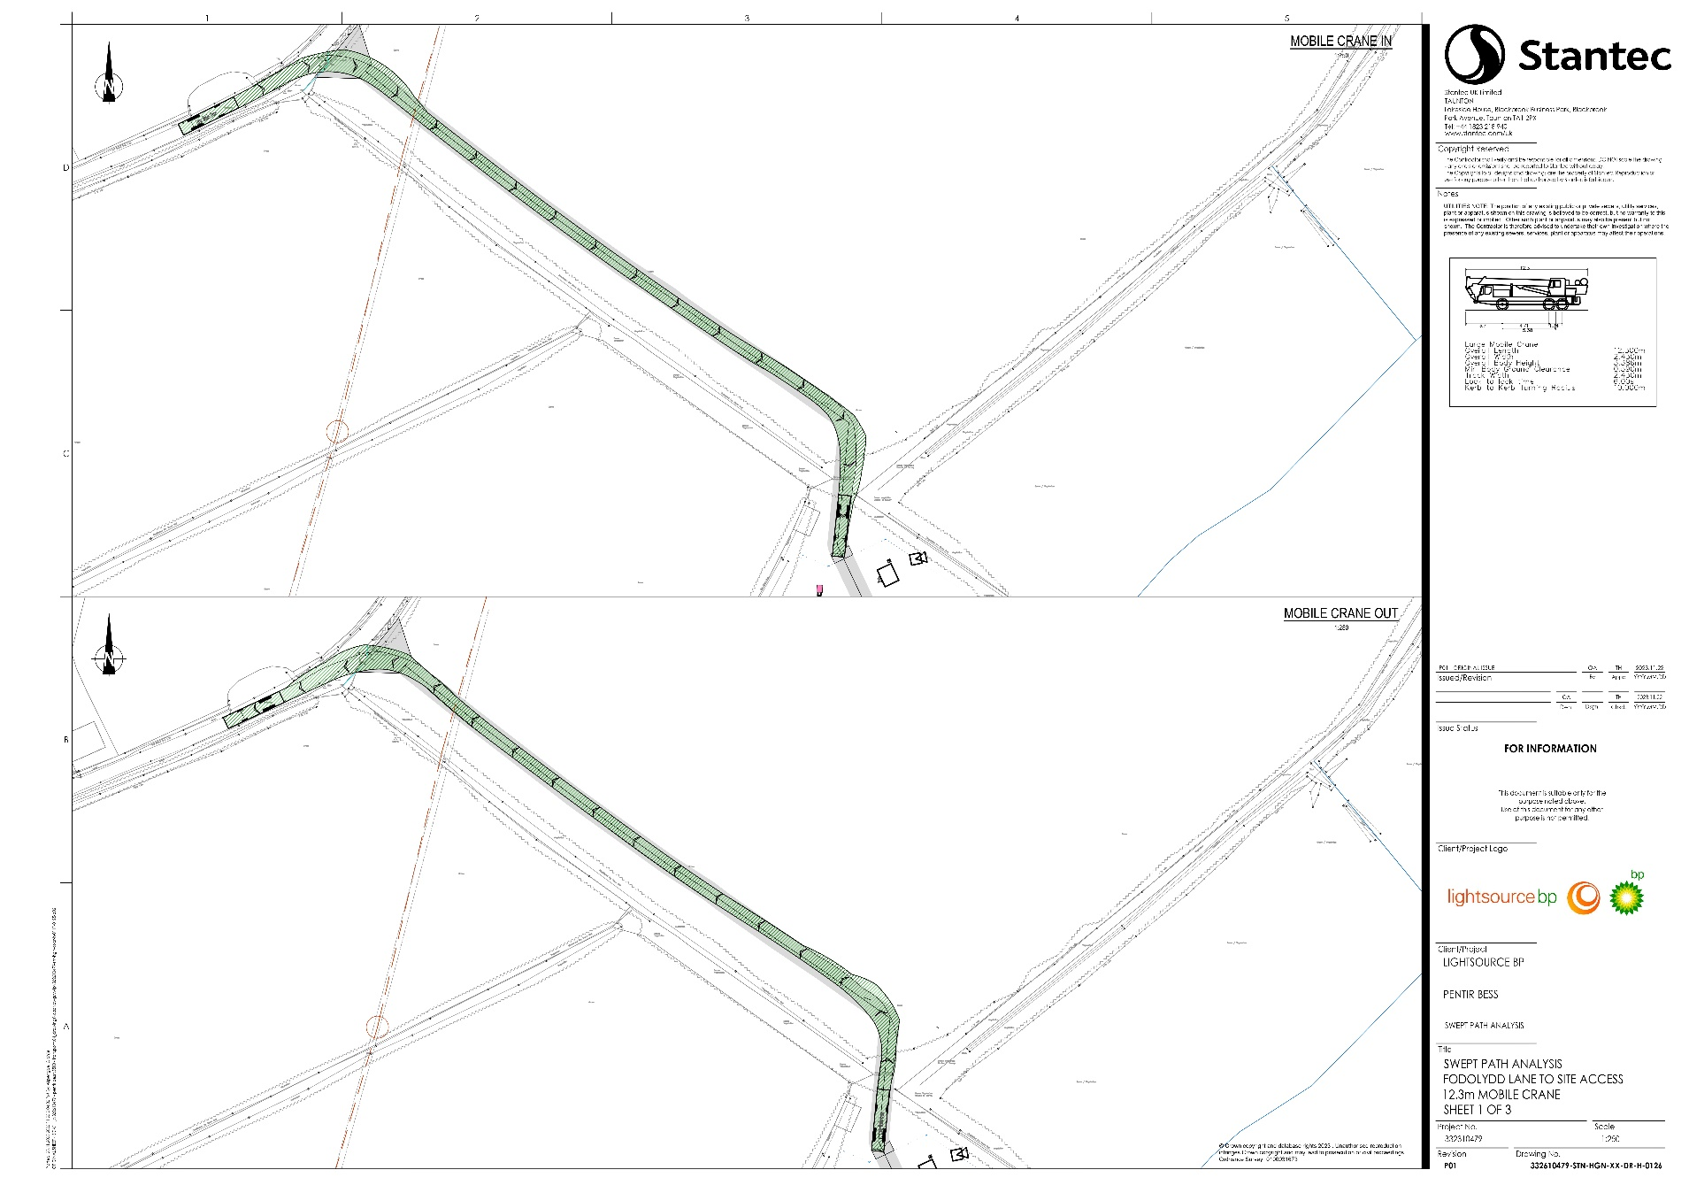
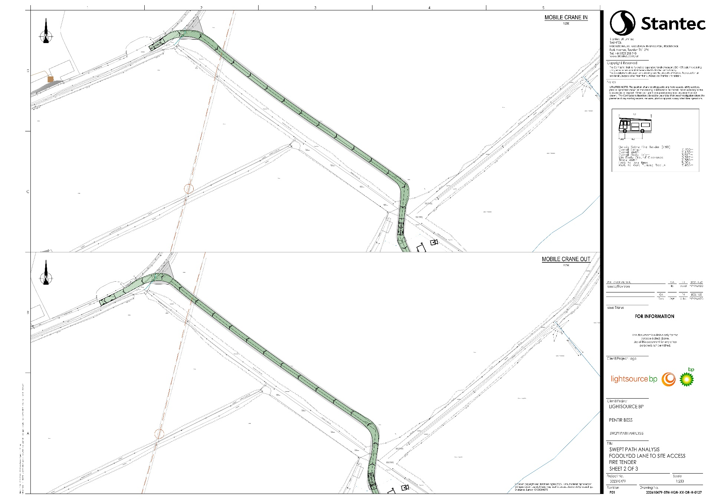
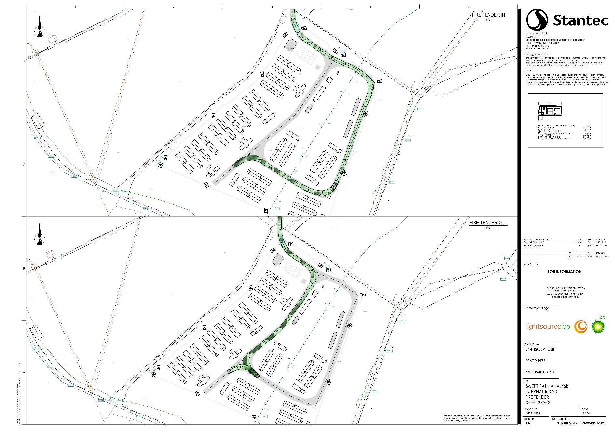
- Swept Path Analysis - Internal Road

Passenger Car Unit is a standardised metric to represent a unit of traffic which is roughly equivalent to one car. A heavy goods vehicle would typically be represented by 2.0-2.5 PCUs.

